# 14. Spring MVC

-Presentation layer is the front door into your app.

-Some major considerations when developing web applications: performance, user-friendliness, interactivity and richness, accessibility

## 14.1 Setting up the Data and Lower-Level Layers

-(See in book)

## 14.2 Introduce MVC

-MVC in pattern in implementing the presentation layer of app. Main principle of MVC: define an architecture with clear responsibilities for different components.

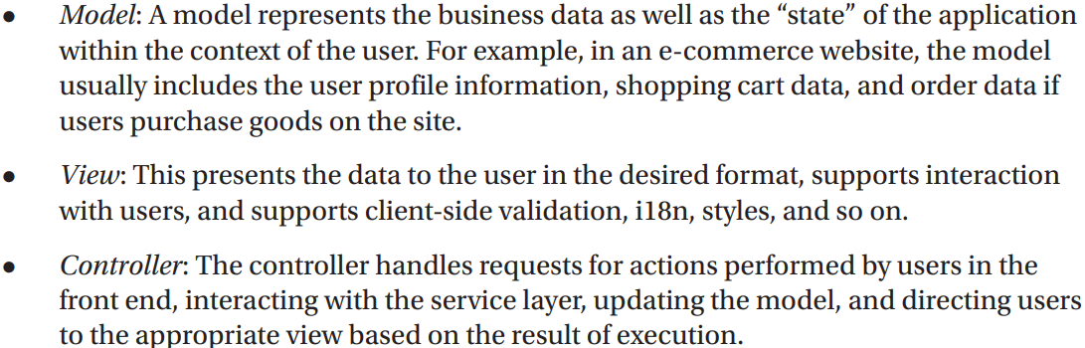

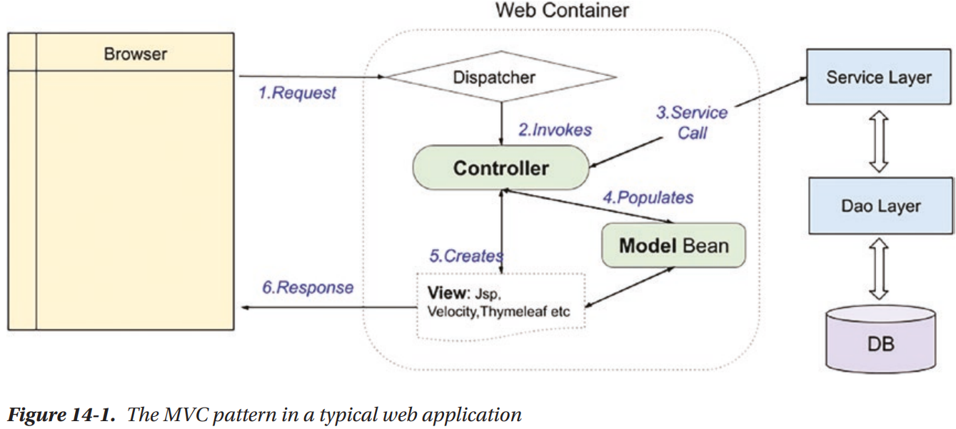

-A normal view request is handled:

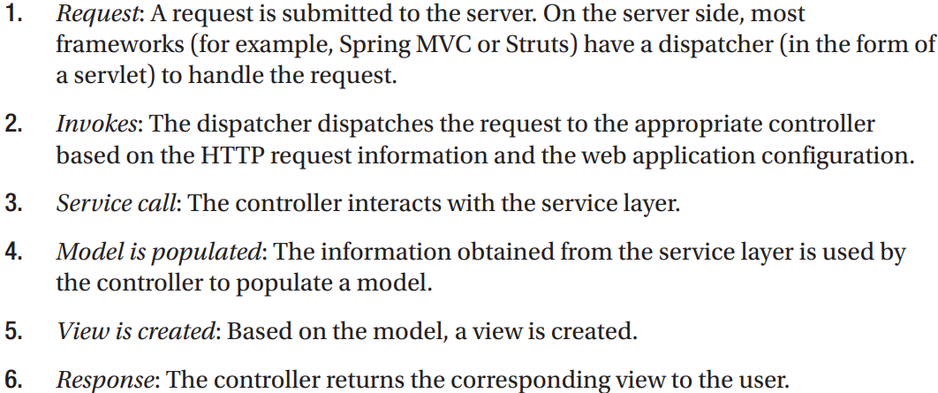

## 14.3 Introduce Spring MVC

-In Spring Framework, Spring MVC module provides support for MVC pattern with support features (theming, i18n, validation, type conversion, formatting)

### 14.3.1 Spring MVC WebApplicationContext Hierarchy

-**DispatcherServlet**: the central servlet that receives requests and dispatches them to appropriate controllers. There can be any number of DispatcherServlet instances for various purposes (UI requests, RESTful-WS requests). Each DispatcherServlet has its own WebApplicationContext configuration which defines servlet-level characteristics.

-Spring MVC maintains a root WebApplicationContext which includes application-level configurations (back-end data source, security, service, persistence layer configuration). The root WebApplication will be available to all servlet-level WebApplicationContexts

-Example: 2 DispatcherServlet instances: application servlet and RESTful servlet.

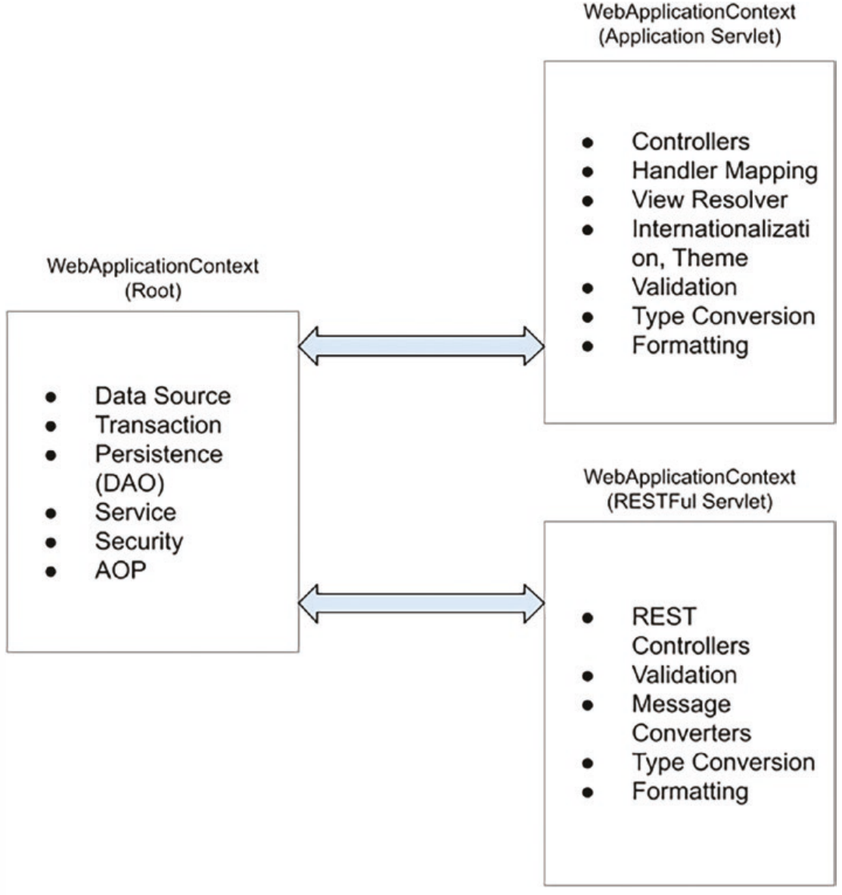

### 14.3.2 Spring MVC Request Life Cycle

-Main components involved in handling a request in Spring MVC:

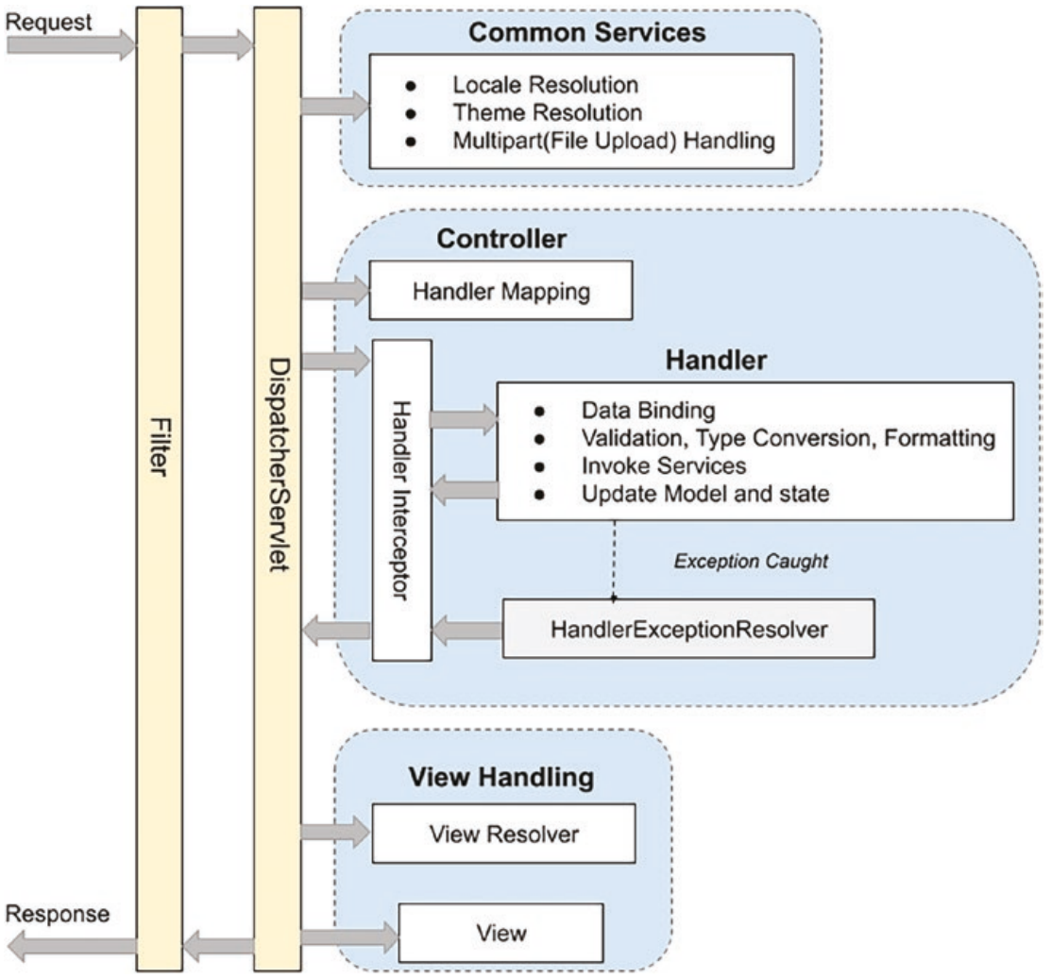

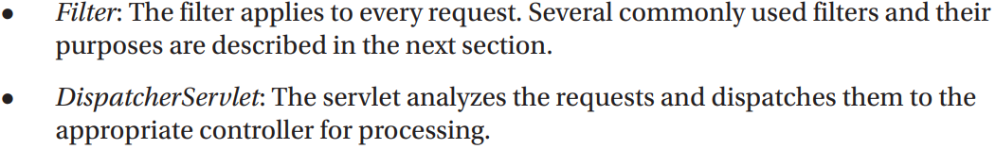

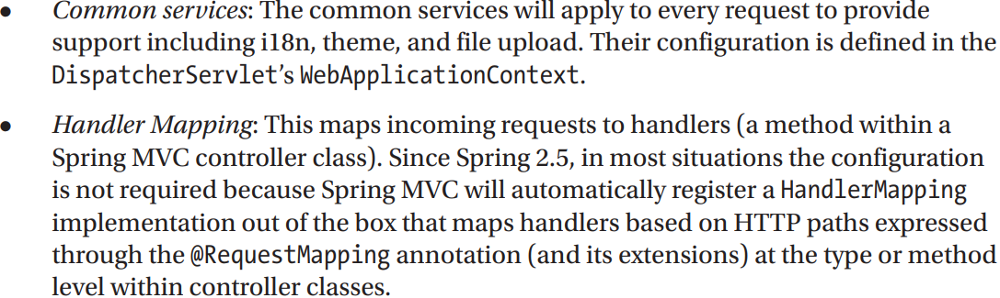

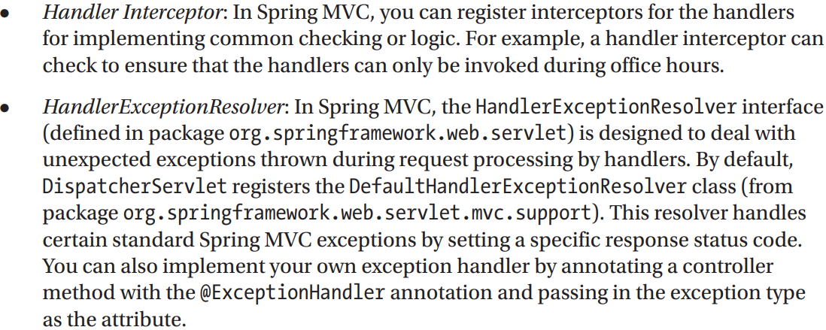

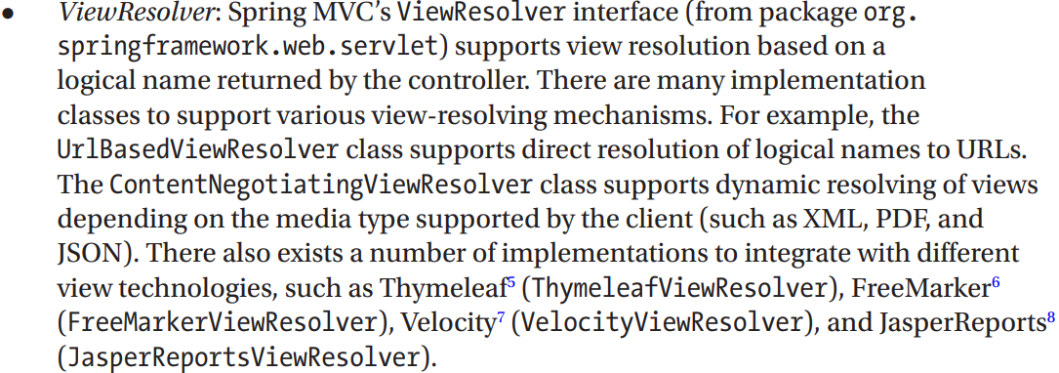

### 14.3.3 Spring MVC Configuration

-To **configure Spring MVC support** for web applications, perform configurations for web deployment descriptor:

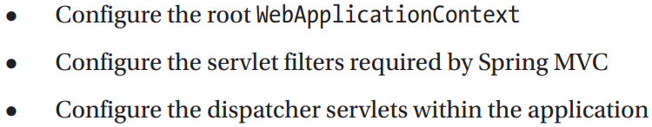

-The **easiest way** is to extend **AbstractAnnotationConfigDispatcherServletInitializer**

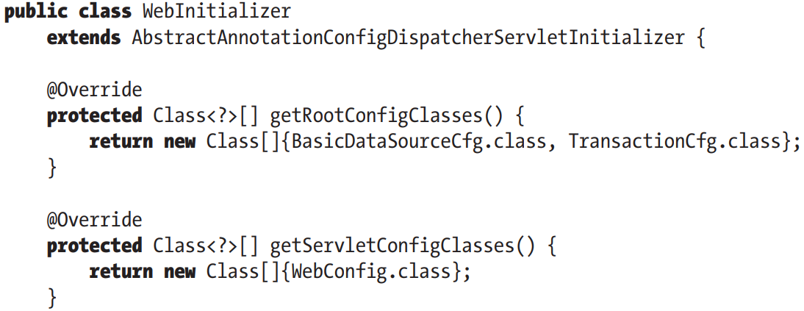

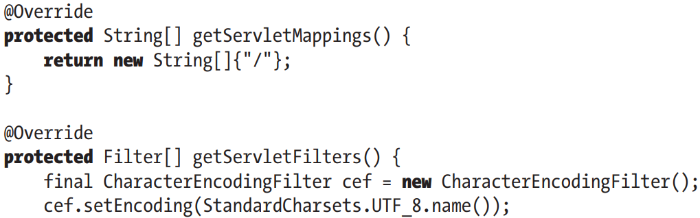

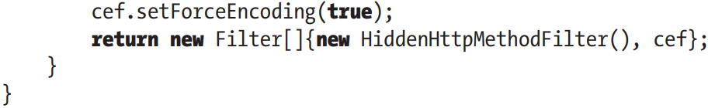

-AbstractAnnotationConfigDispatcherServletInitializer implement **WebApplicationInitializer**: in order to configure **ServletContext**.

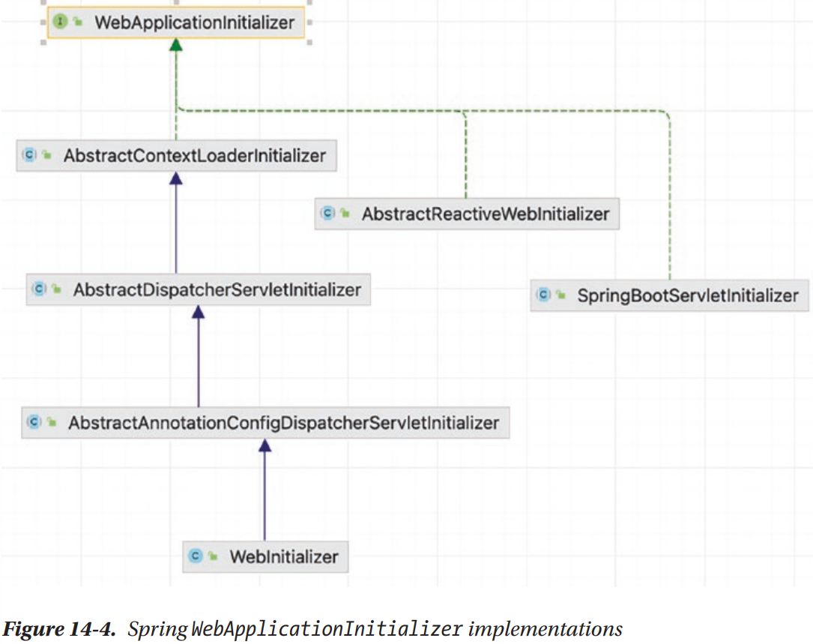

-All classes implement **WebApplicationInitializer** are automatically detected by **SpringServletContainerInitializer** (implement **ServletContainerInitializer**, which bootstrap automatically in Servlet 3.0 containers)

-Overridden methods:

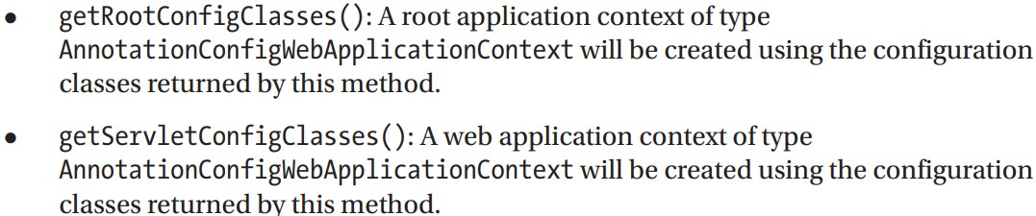

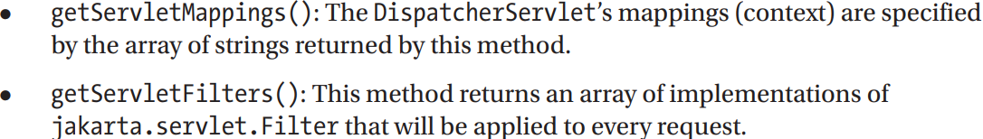

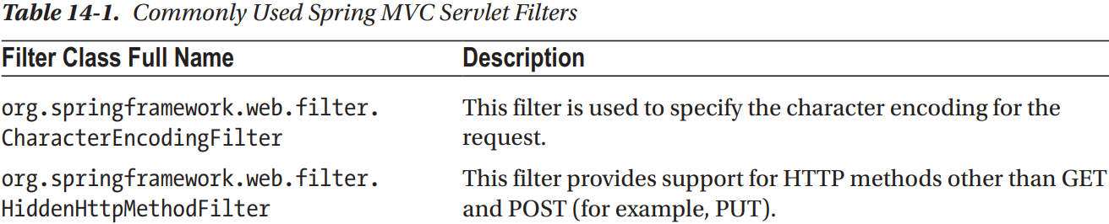

### 14.3.4 Create the 1st View in Spring MVC

-Thymeleaf: server-side Java template engine for both web and stand-alone environments, it integrates smoothly with Spring applications since it was created specially for them.

-Dependencies: Jakarta.servlet-api, spring-webmvc, thymeleaf-spring

### 14.3.5 Configure DispatcherServlet

-Configuration class that defines all infrastructure beans needed for Spring web application:

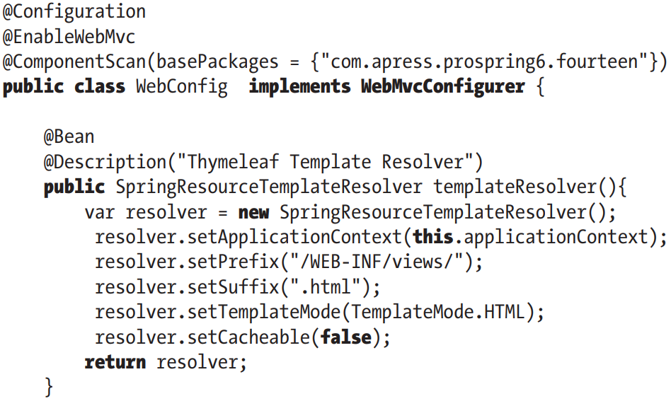

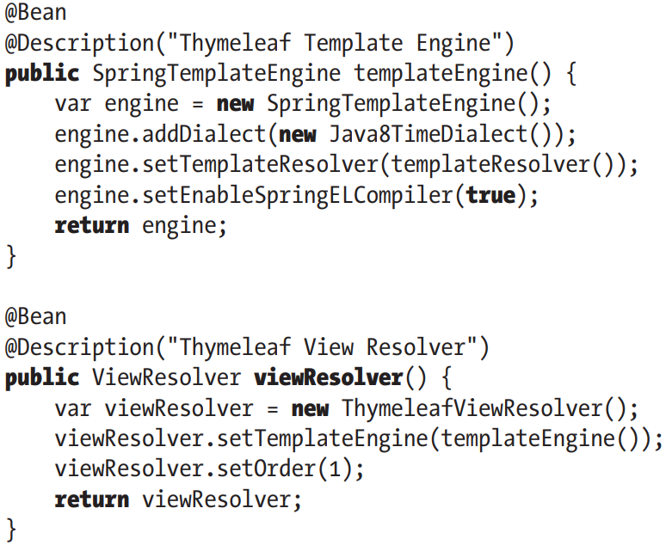

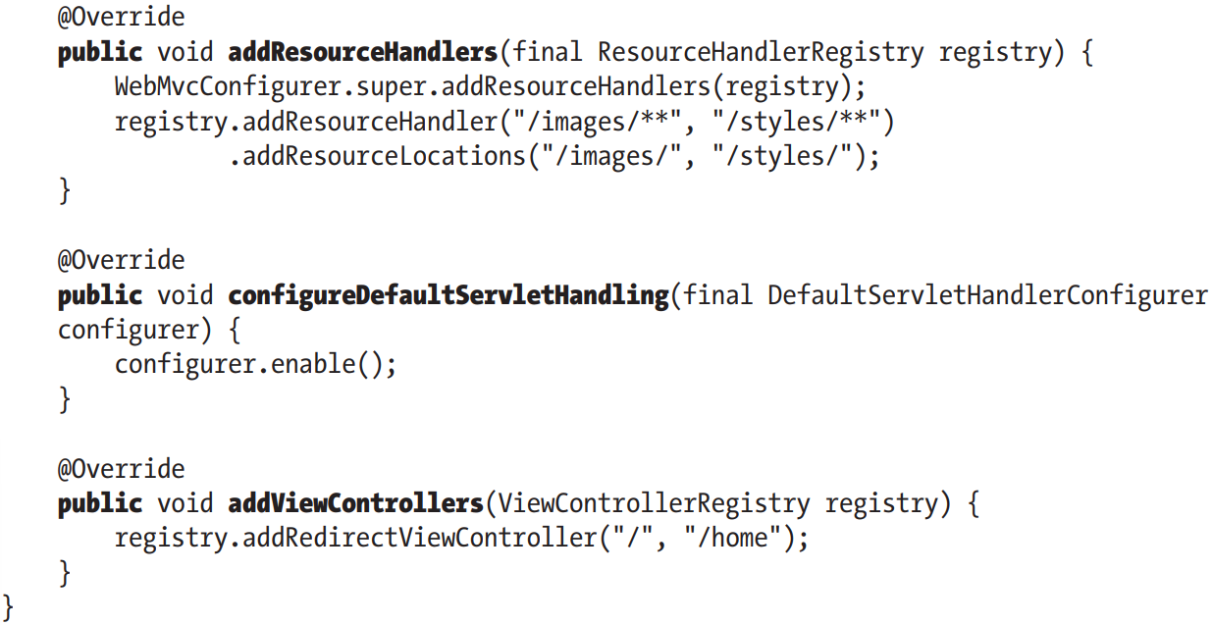

-**WebMvcConfigurer**: defines callback methods to customize configuration for Spring MVC enabled by @EnableWebMvc.

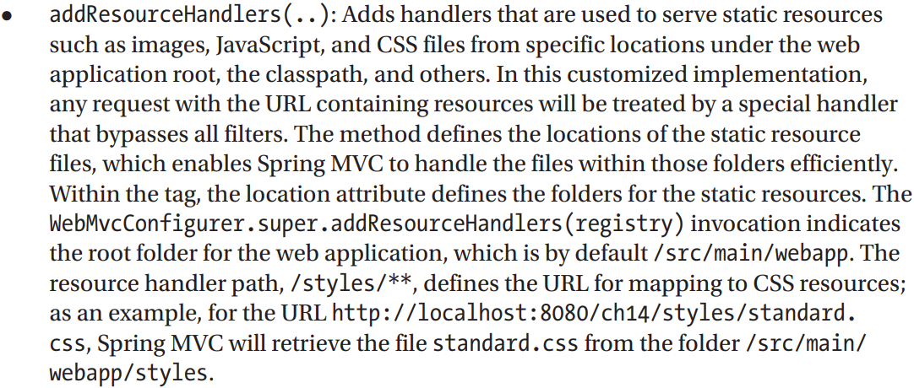

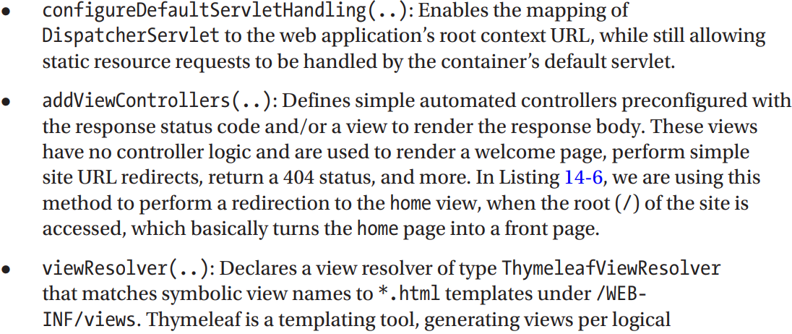

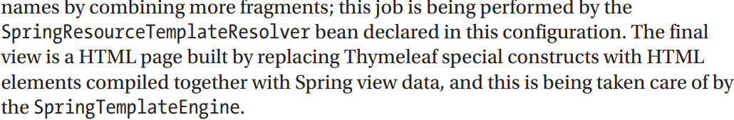

### 14.3.6 Implement Spring Controllers

-HomeController:

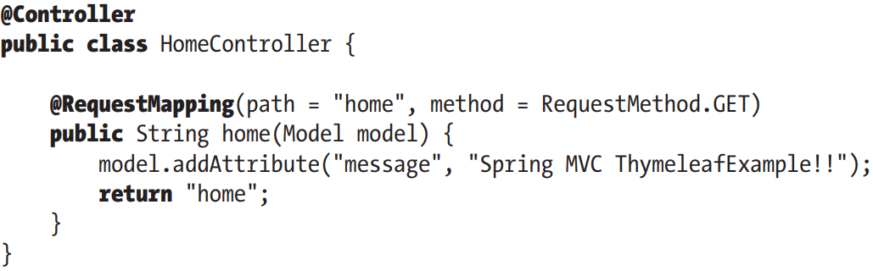

-The controller class is sometimes called a handler, the methods are handler methods.

### 14.3.7 Implement the View

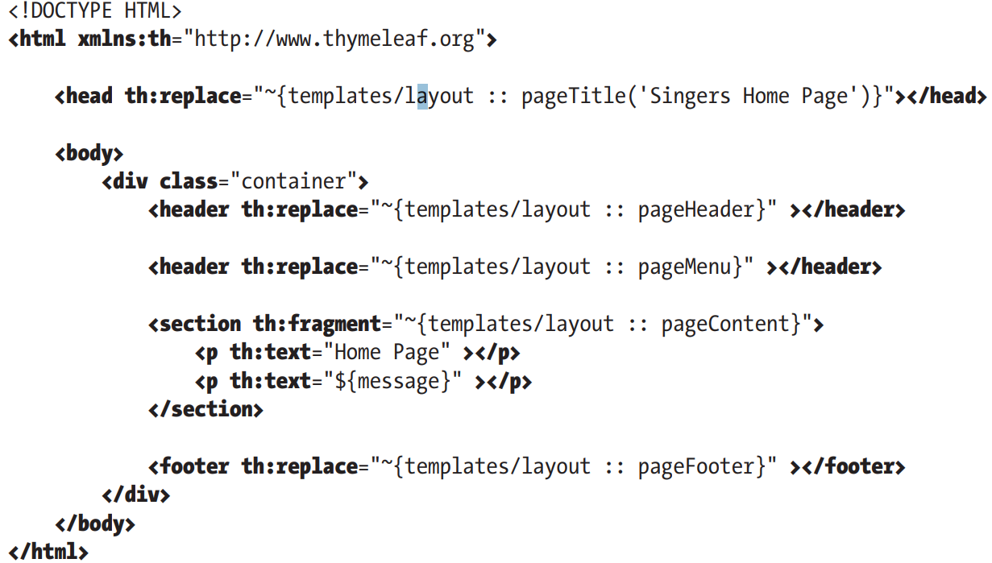

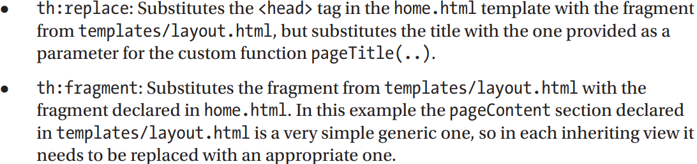

### 14.3.8 Testing the Home View

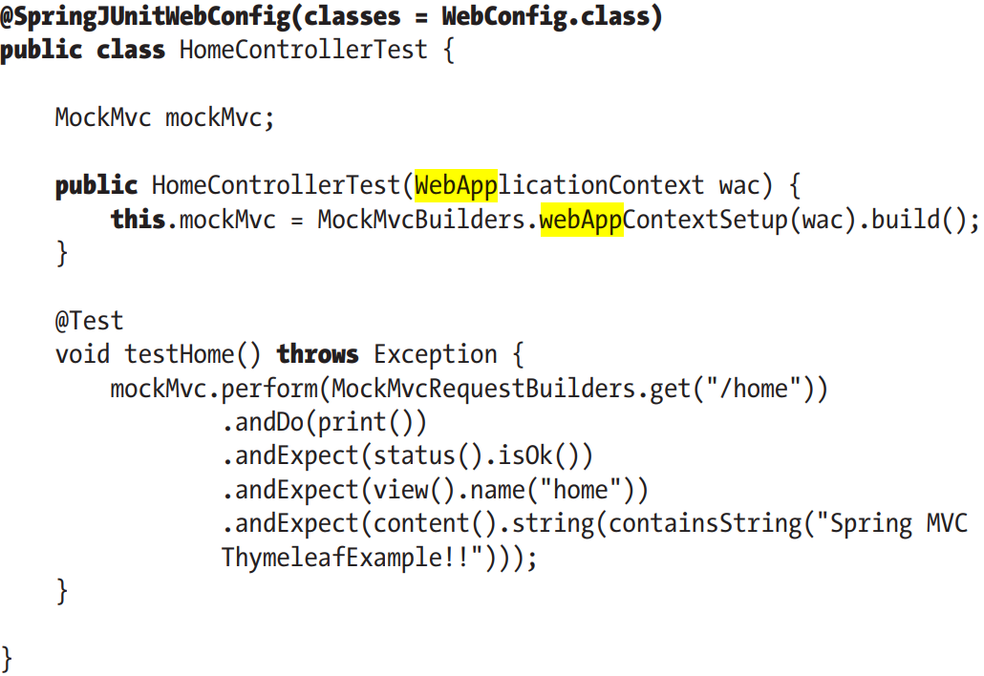

### 14.3.9 Understand the Spring MVC Project Structure

-In web application, lots of files are required to support various features. It’s good practice to store files that serve different purposes in well-structured folder hierarchy:

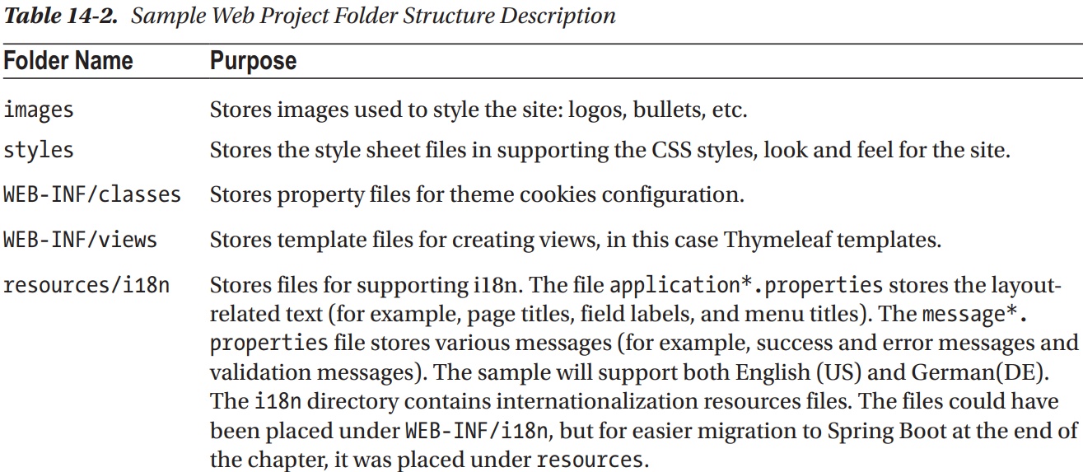

## 14.4 Enabling Internationalization (i18n)

-Enabling i18n: externalize language-related UI settings into various properties files in /resources/i18n

### 14.4.1 Configure i18n in DispatcherServlet Configuration

-Add internationalization configuration: declare MessageSource bean, inject it in template resolver, add request interceptors to replace all message codes in view templates with test representations in configured language.

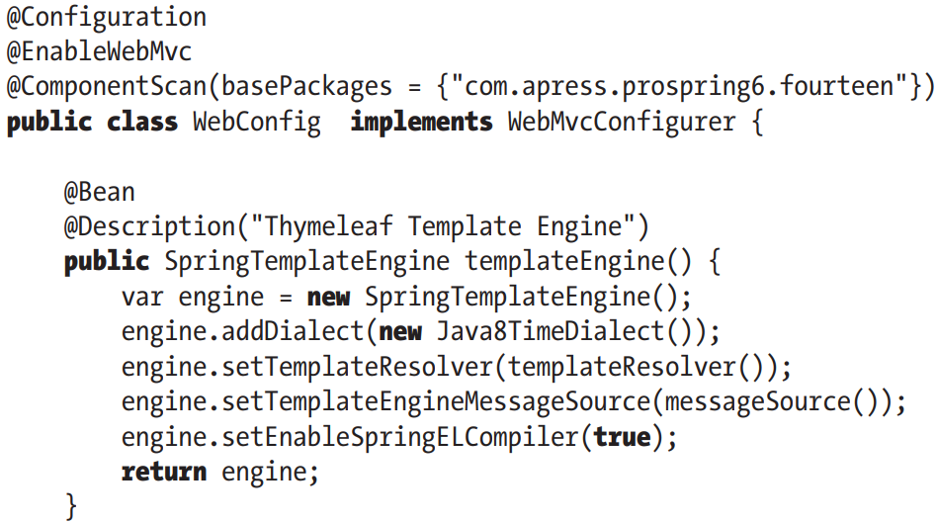

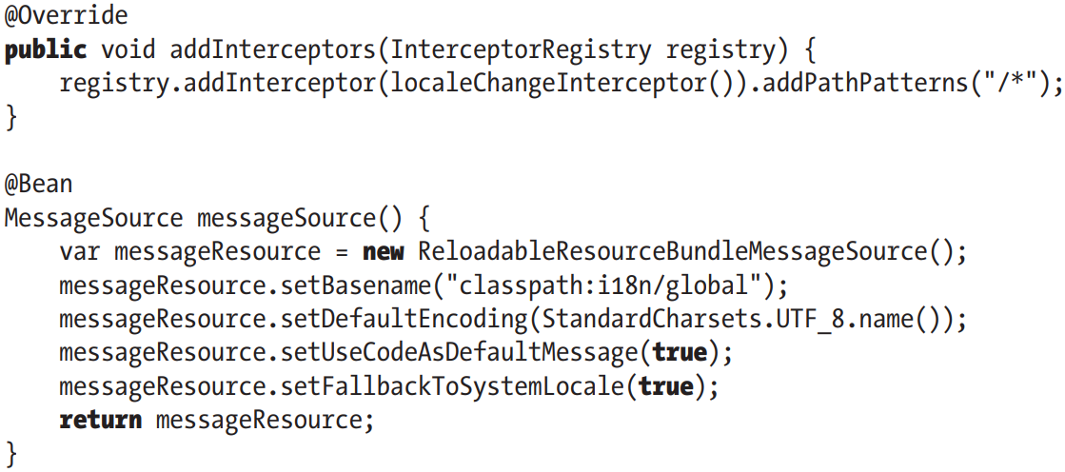

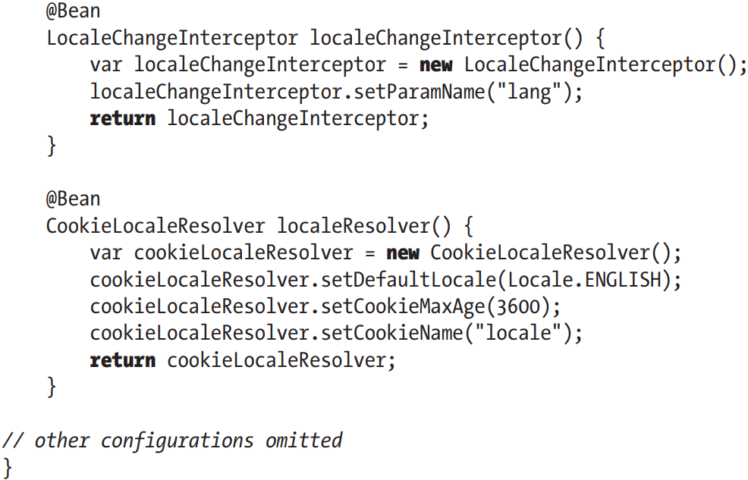

+**MessageSource** bean is declared as **ReloadableResourceBundleMessageSource** which implements MessageSource: load messages from defined files to support i18n.

+**setFallbackToSystemLocale()**: whether to fall back to local of system when a special resource bundle isn’t found.

+**LocaleChangeInterceptor**: support locale switching with a customizable request parameter.

+**CookieLocaleResolver**: support the storage and retrieval of locale settings from user browser’s cookie

### 14.4.2 Modify Views for i18n Support

-layout:

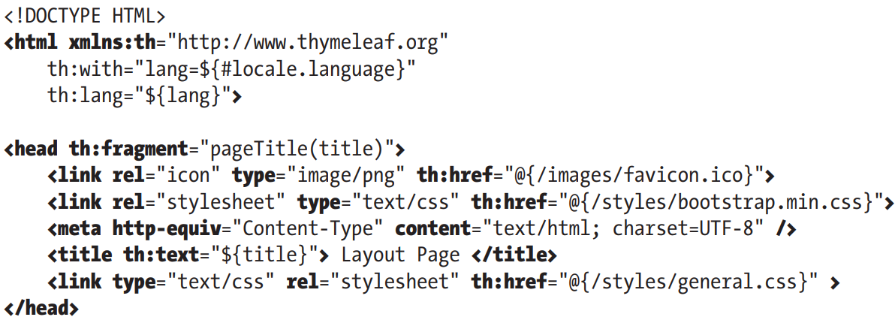

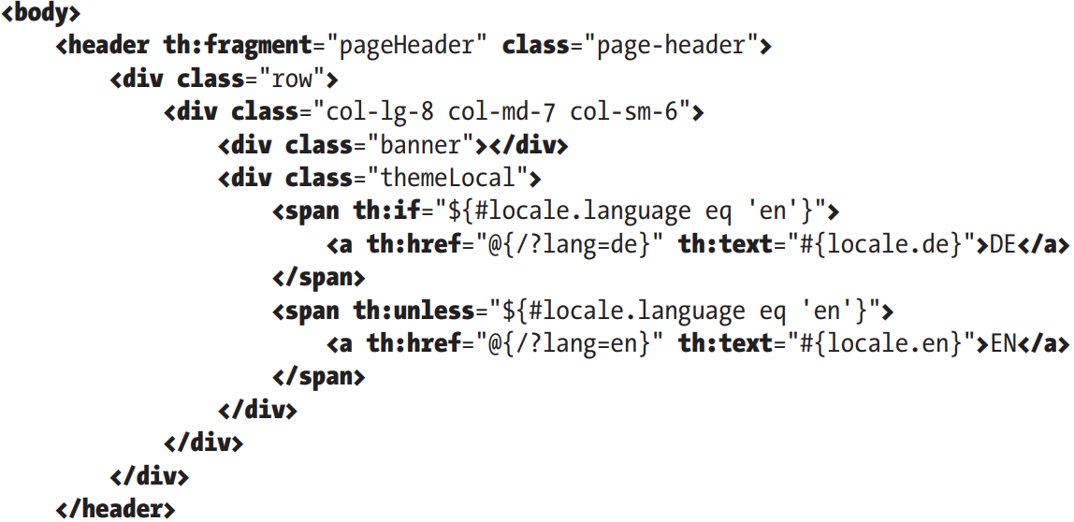

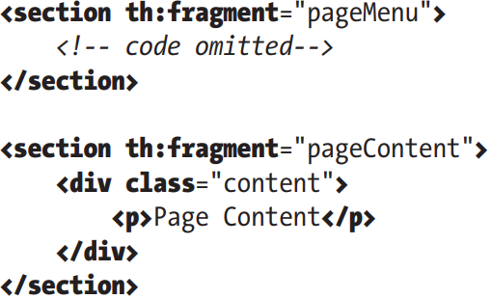

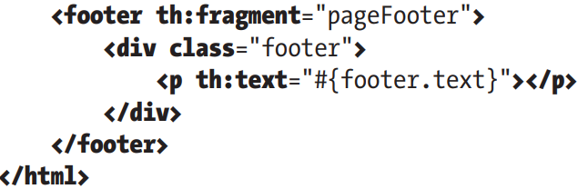

+HTML lang attribute identify then language of text contend on Web. th:lang populates this attribute with value of lang parameter.

+Spring MVC stores locale setting in browser’s cookie and by default kept for user session. You can setCookieMaxAge()

+To switch to English, change URL in browser to ?lang=en. Spring MVC falls back to use default.

+Locale-specific values accessed using keys #{key}

## 14.5 Use Theming and Templating

-Currently, the approach is to keep website separate from back end and create website using evolved JS frameworks (React…) that interacts with Spring REST Web.

-(See in book)

## 14.6 Implement more Complex Views

-The best practices is to follow RESTful-style URL for mapping views.

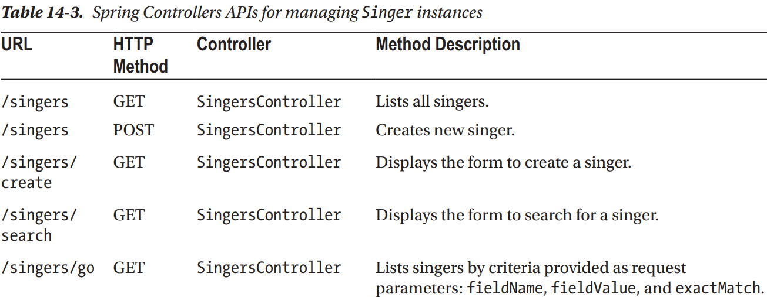

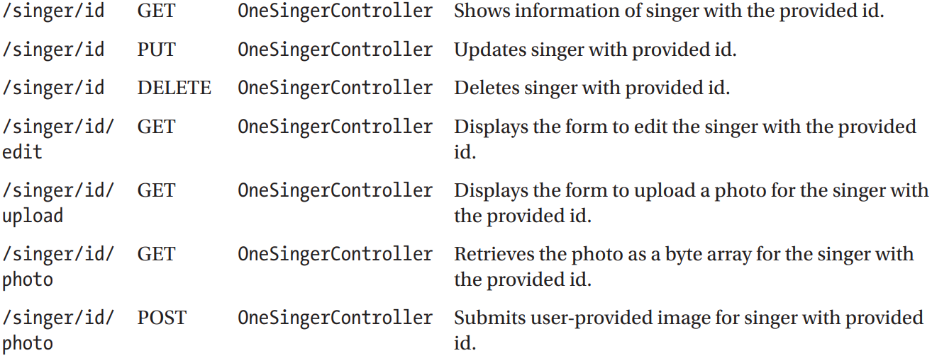

-Implement the List Singers View

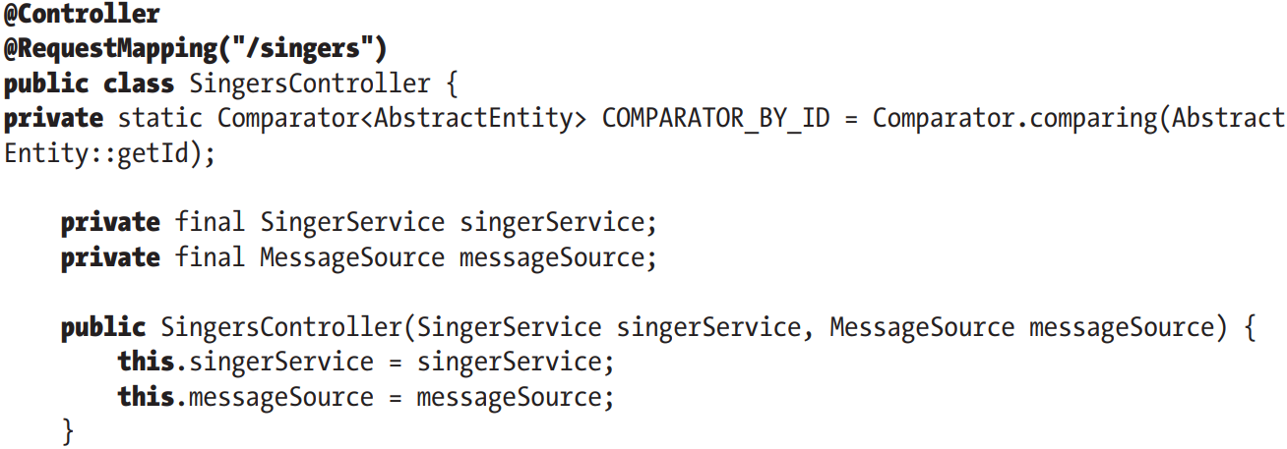

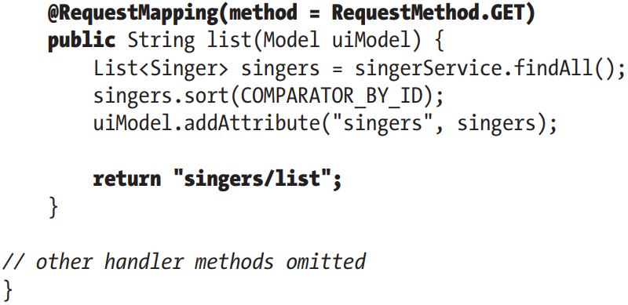

-Implement the Show Singer View

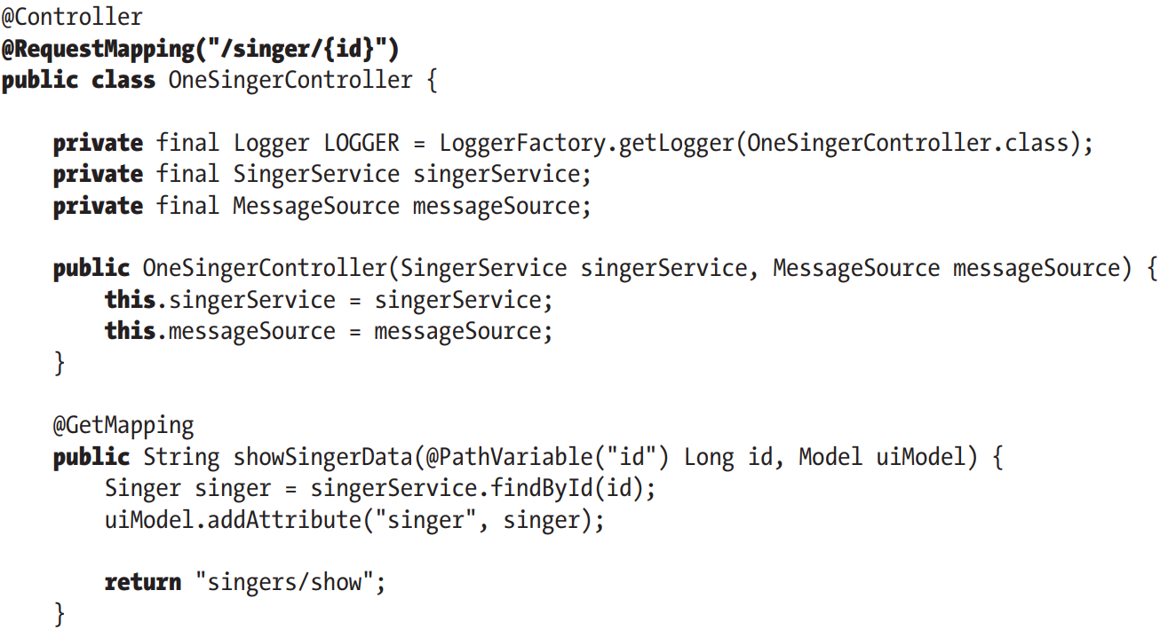

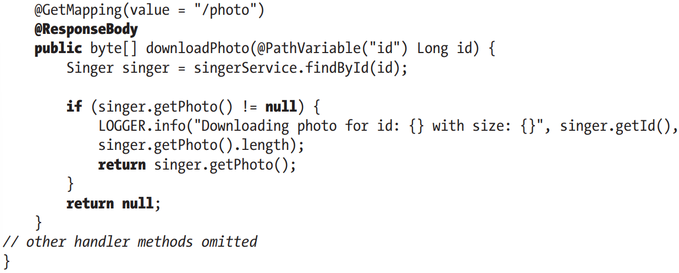

-Handle a Delete Request

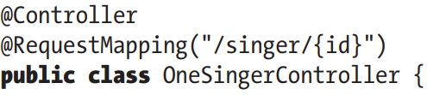

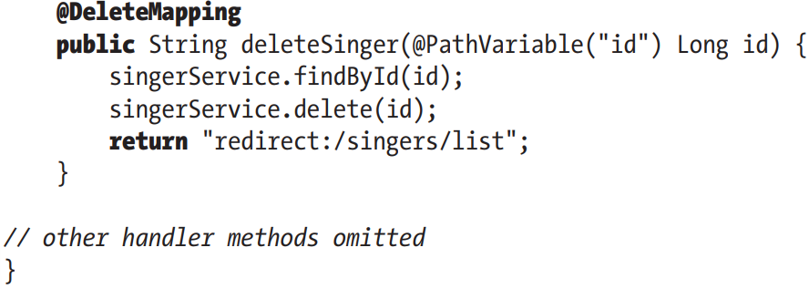

+Configuration to support PUT and DELETE methods

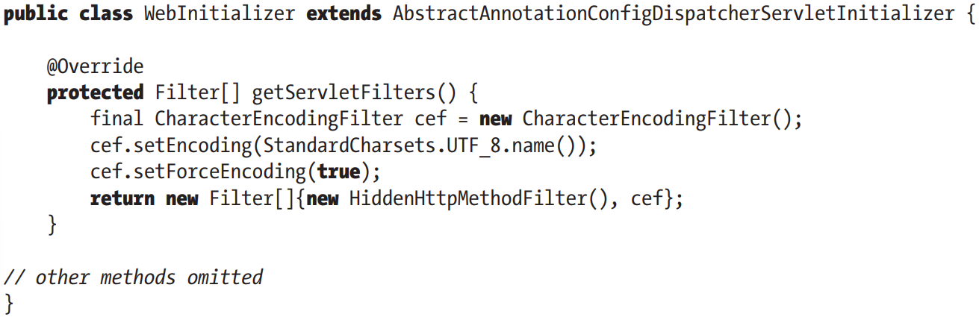

-Implement Edit Singer View

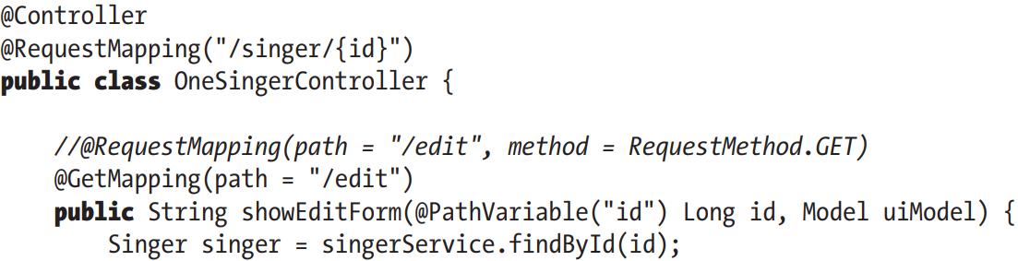

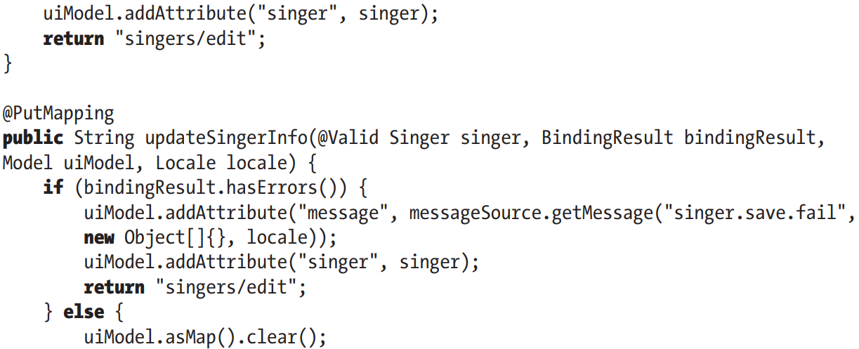

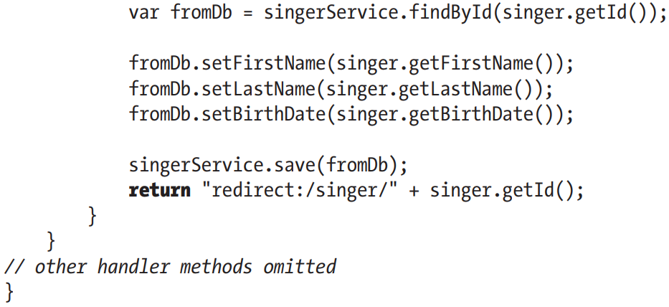

-Implement Create Singer View

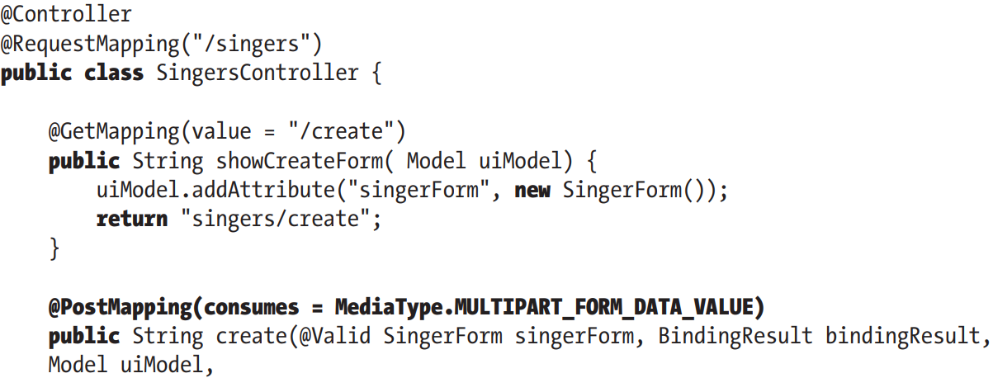

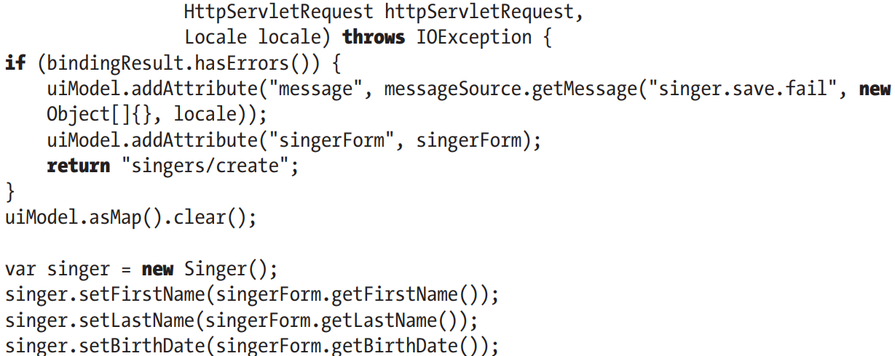

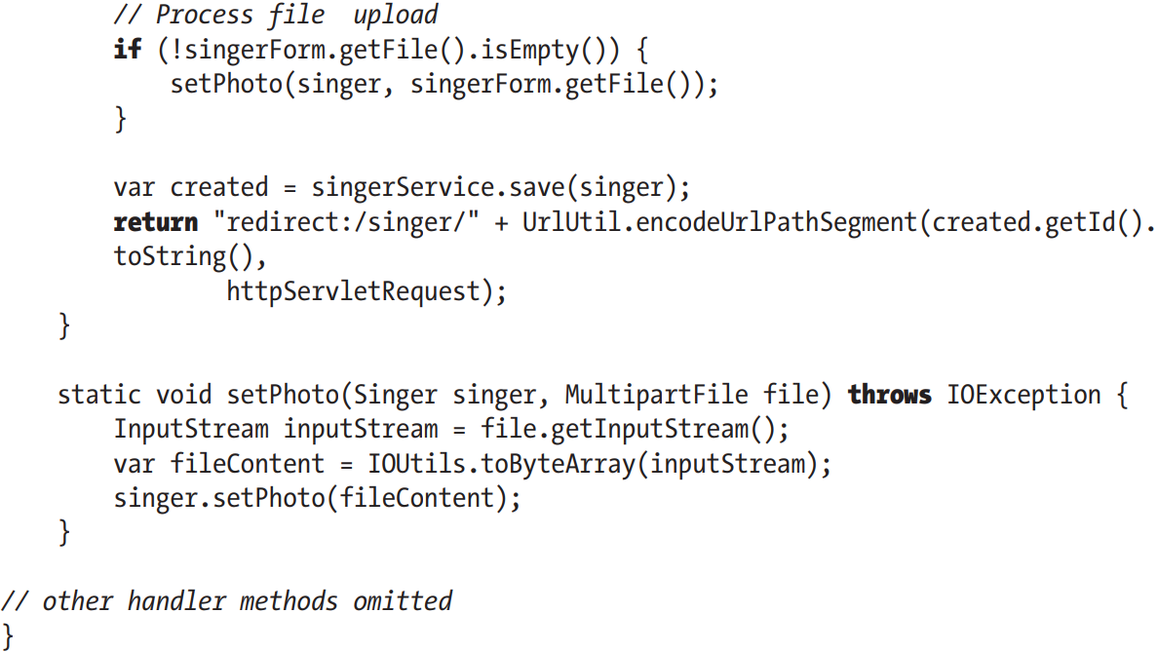

+In complex application, the entity types declared in DAO layer are never used in controllers, in web layer. Usually view types are introduced that wrap around one or more entity types and expose only useful fields, hiding details such as sensitive data (identifiers, passwords, fields that are not relevant to web context, like version field).

-SingerForm: view type that declares only fields necessary for creating Singer instance for web level



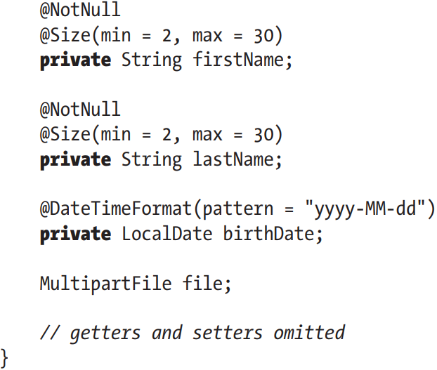

-File upload:

+Spring Bean for Support File Upload

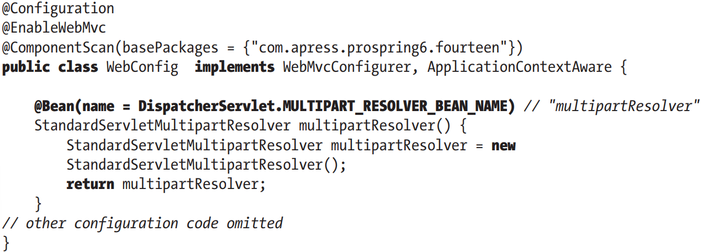

+Enable MultiParsing 3.0+ environments:

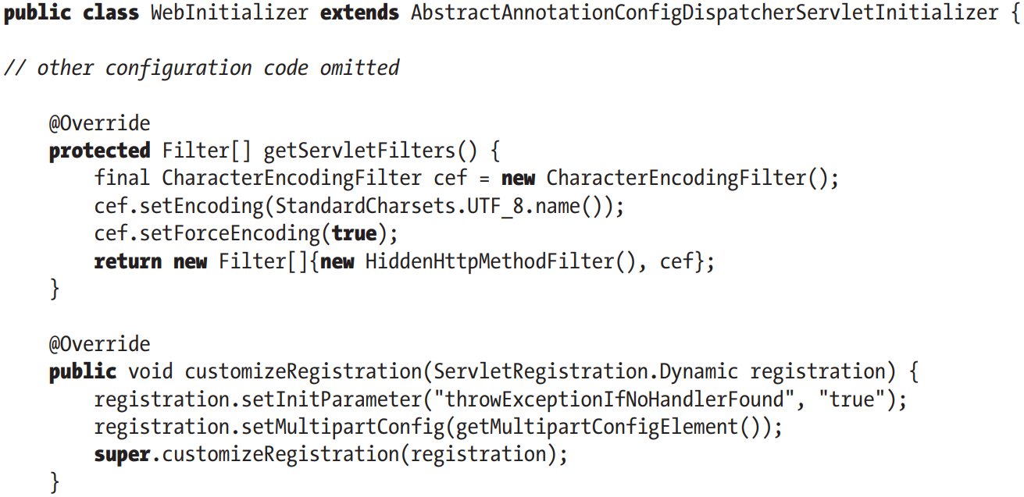

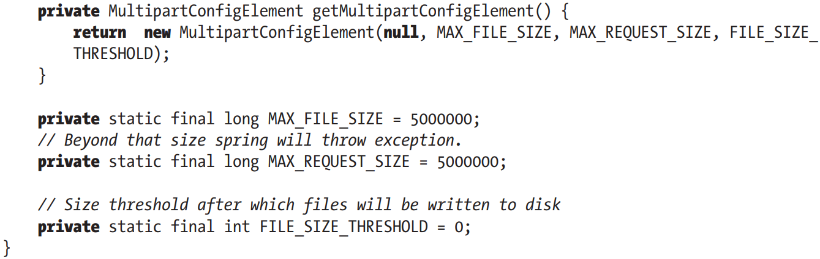

## 14.7 Enabling JSR-349 (Bean Validation)

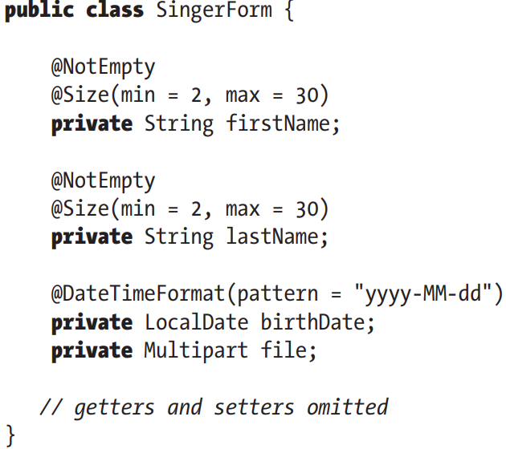

-For validation message, you specify a message key by using {}. This make it to be retrieved from ResourceBundle and hence support i18n.

+Error message codes are resolved by **MessageCodesResolver** bean registered automatically by Spring when validation is configured. The default implementation is **DefaultMessageCodesResolver**: create 2 message codes: based on name of type and based on field names.

+Example: firstName filed in class SingerForm annotated with @Size, this bean will create a group of message codes resolved in order:

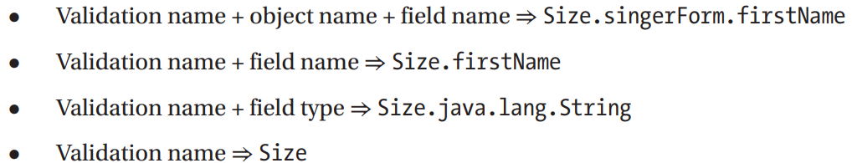

If neither of these is declared, the default message is set to annotation full name + “message”

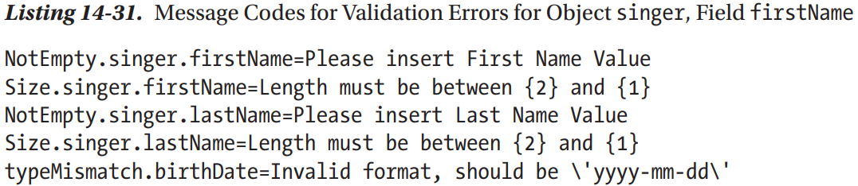

-We can use message attribute:

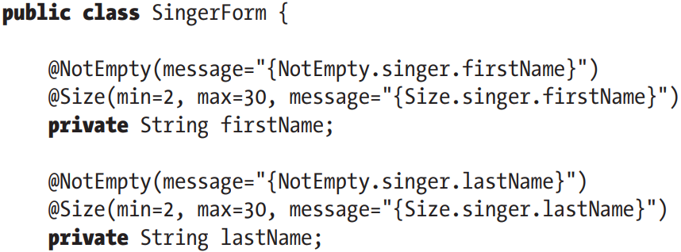

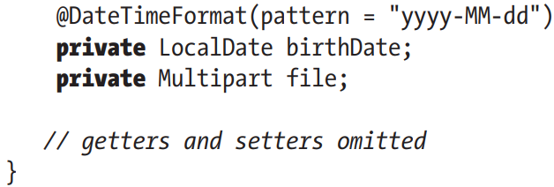

-To enable JSR-349 during web data binding process, use **@Valid**

-Make JSR-349 validation message use the same ResourceBundle instance as for the views

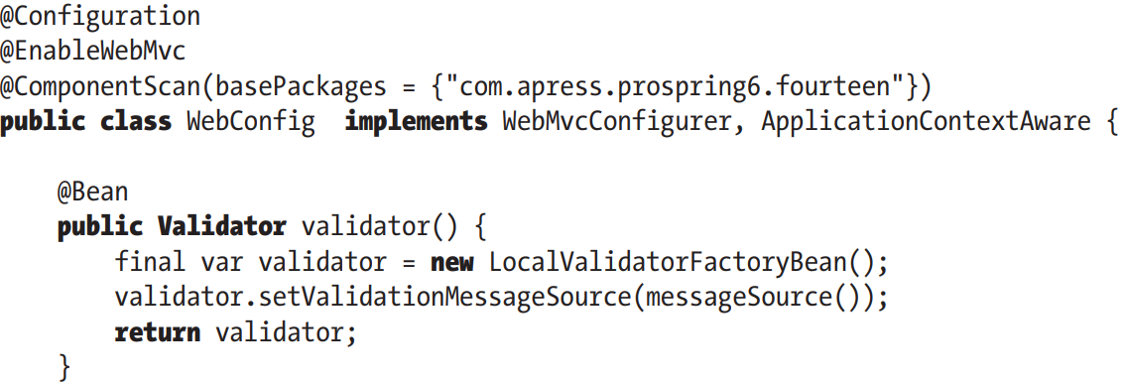

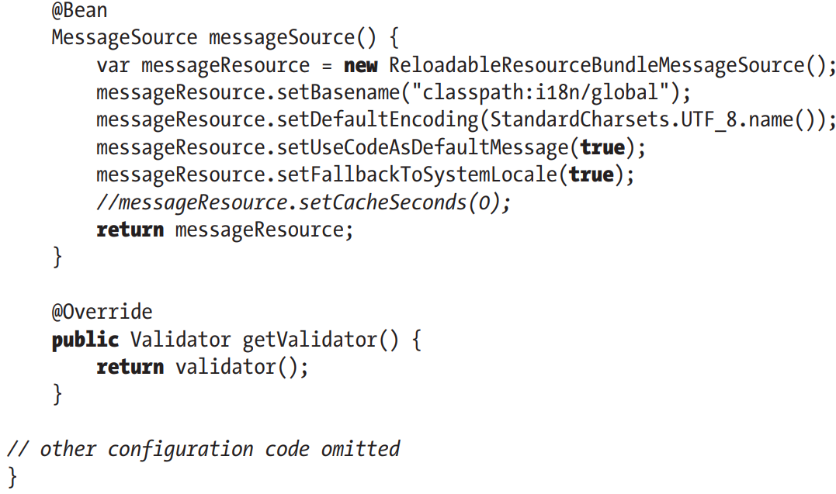

+Validator bean **LocalValidatorFactory** bean for JSR-349 support. We use **setValidationMessageSource()** to reference the MessageSource bean which instruct JSR-349 validator to look up messages by the code from MessageSource bean.

## 14.8 Exception Handling

-Spring MVC catches and handles exceptions using implementations of **HandlerExceptionResolver**.

-The typical way to treat MVC exception is to prepare a model and select an error view. Multiple exception resolvers can be used and ordered in a chain to treat different type of exceptions.

-Spring MVC supports **default resolvers**, declared in DispatcherServlet.properties file in spring-webmvc

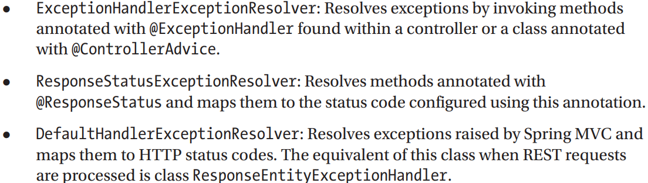

-**SimpleMappingExceptionResolver**: beans of this type can configured to map exception classes to view names->render error pages in browser application

-Exception resolver provides information: handler method + arguments.

-Instead of Apache Tomcat page, we can display a customized error view. Spring MVC offers no default (fallback) error page when a view or a handle method is not found. It just forwards showing message to server. To override this behavior:

+Customize DispatcherServlet to throw NoHanlderFoundException when handler method can’t be found: customizeRegistration()

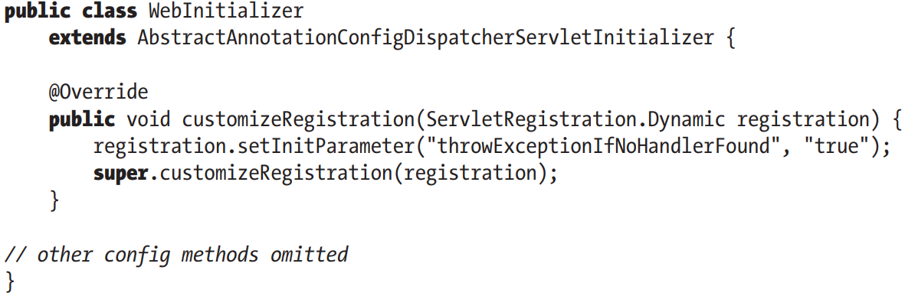

+**Remove** DefaultServletHttpRequest (always forwarded to it):

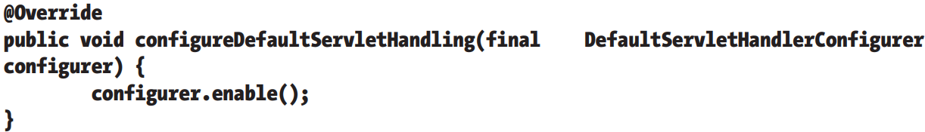

+2nd: HanderExceptionResolver implementation:

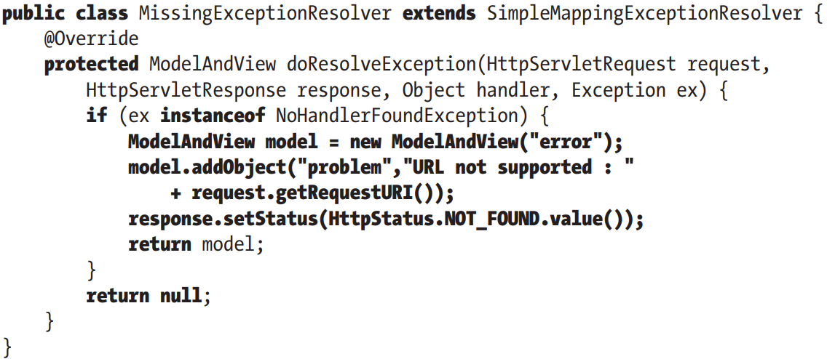

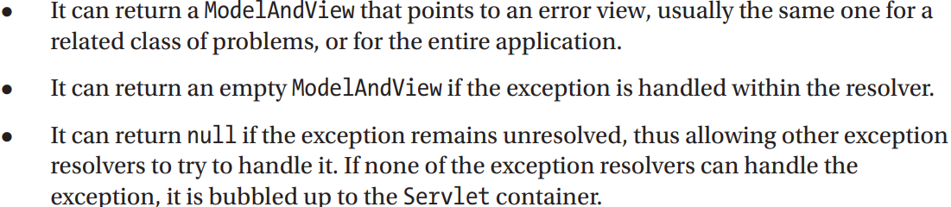

-3rd step: declare bean of this type with lowest priority (highest precedence), so that when sth goes wrong, this exception resolver will be used first

**+@ControllerAdvice**: declare different error handle methods and group all of them. This bean intercepts exceptions thrown by handler methods and maps them to @ExceptionHandler methods to process them and render error views.

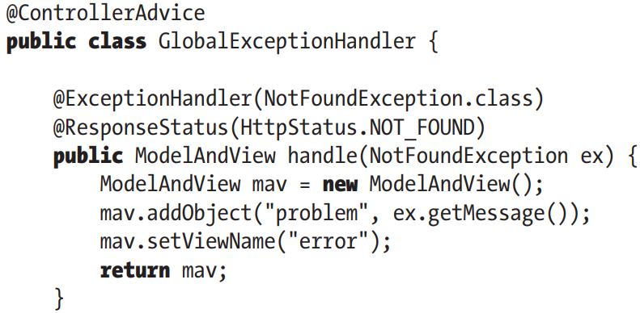

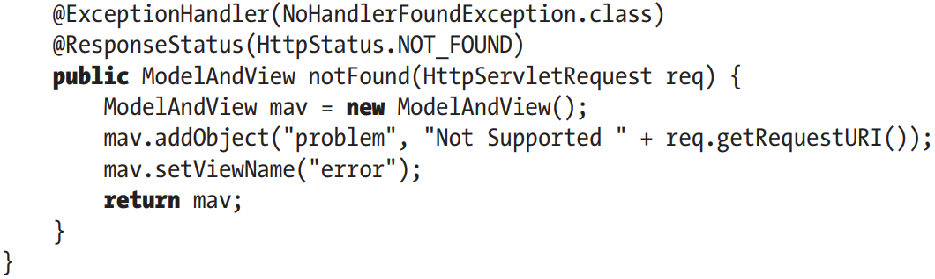

## 14.9 Switch to Spring Boot

-Dependencies: spring-boot-starter-thymeleaf, spring-boot-starter-web, spring-boot-starter-validation, spring-boot-starter-data-jpa

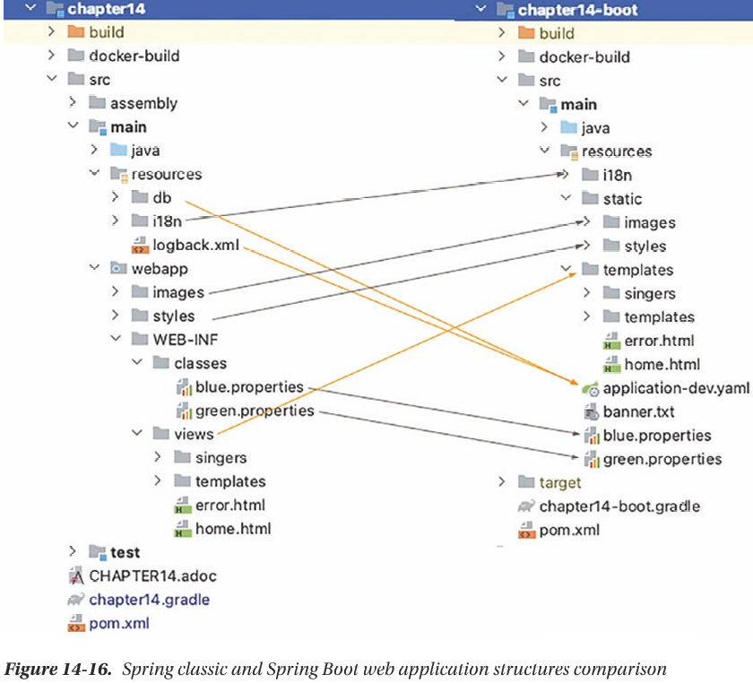

-Spring Boot Web application configuration:

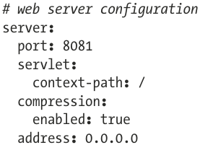

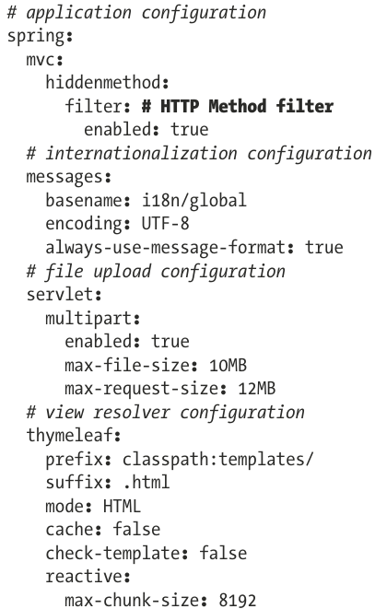

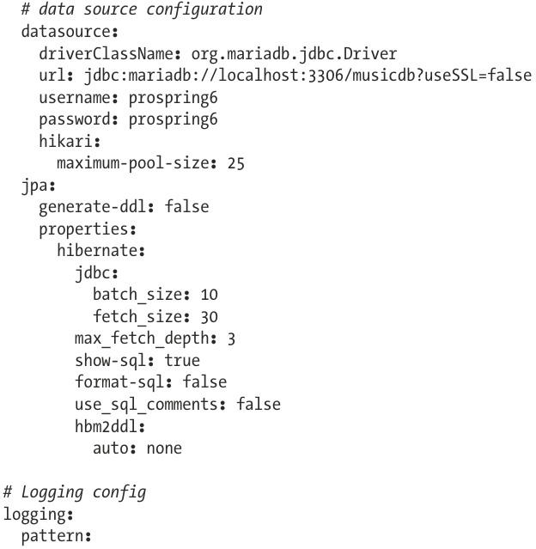

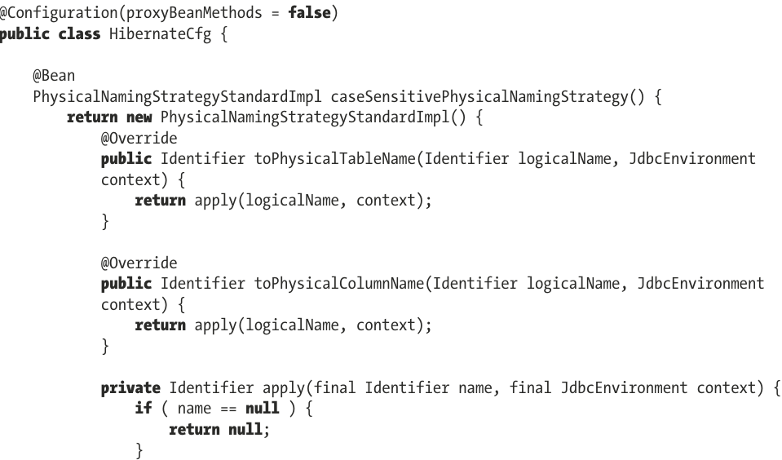

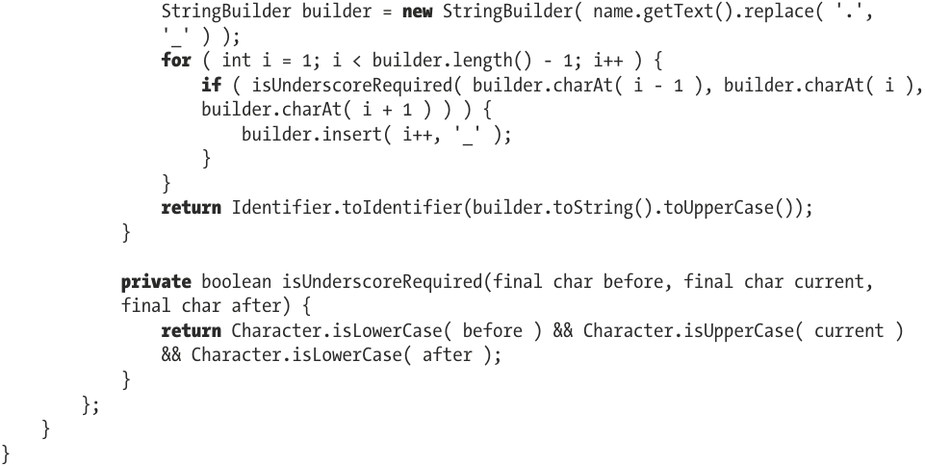

-WebConfig: configure locale and theme interceptors and resolvers (not automatically by SB)

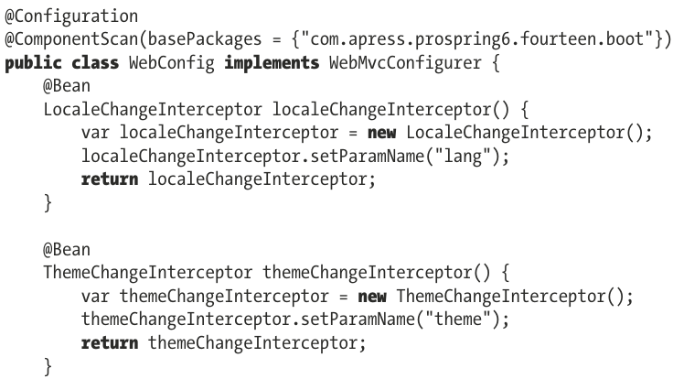

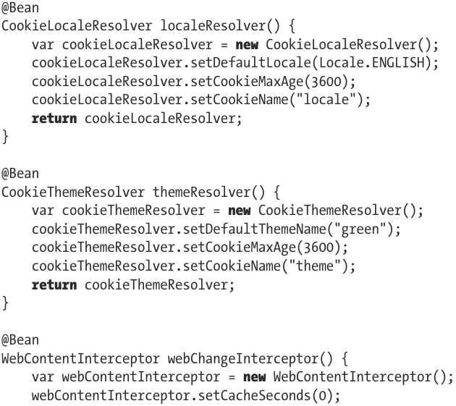

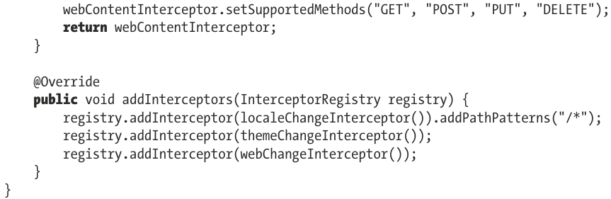

+@EnableWebMvc isn’t needed because SB configures the web application context.

-ApplicationClass:

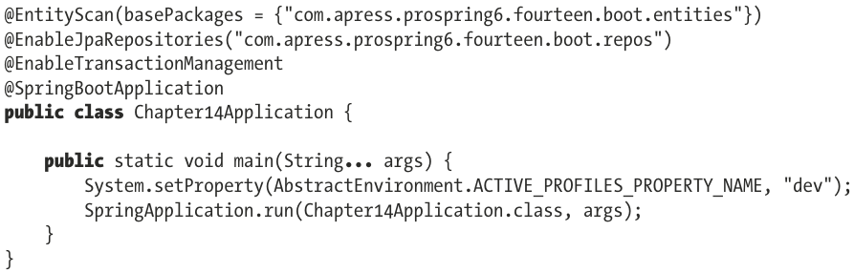

# 15. Spring REST Support

## 15.1 Introduce RESTful Web Services

-**REST**: Representational State Transfer: define a set of architectural constraints that describe a uniform interface for accessing resources. Uniform interface include identification of resources and manipulation of resources through representations.

-For identification of resources, a piece of information should be accessible via **uniform resource identifier (URI)**.

+http://somedomain.com/api/singer/1: This URL is a URI that represents a resource, which is a piece of singer information with an identifier of 1.

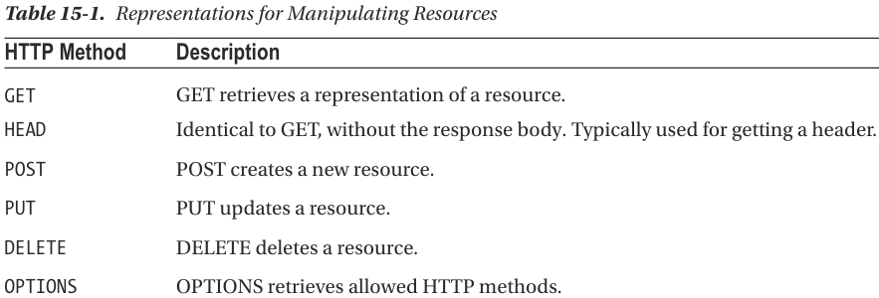

### 15.1.1 Use Spring MVC to Expose RESTful Web Services

-**Jackson library**: provides components for **serializing** objects to JSON and XML.

-Singer Class:

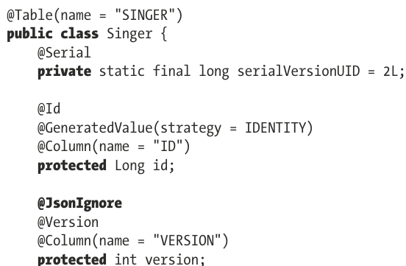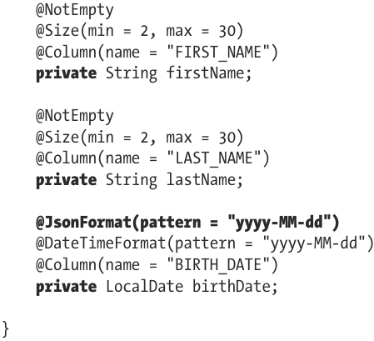

+By **default**, all fields Jackson knows how to serialize to text values are serialized.

+**@JsonIgnore**: fields should not be serialized

+For **complex types**, there are 2 options: **@JsonFormat** or extend **StdSerializer**

### 15.1.2 Implement SingerController

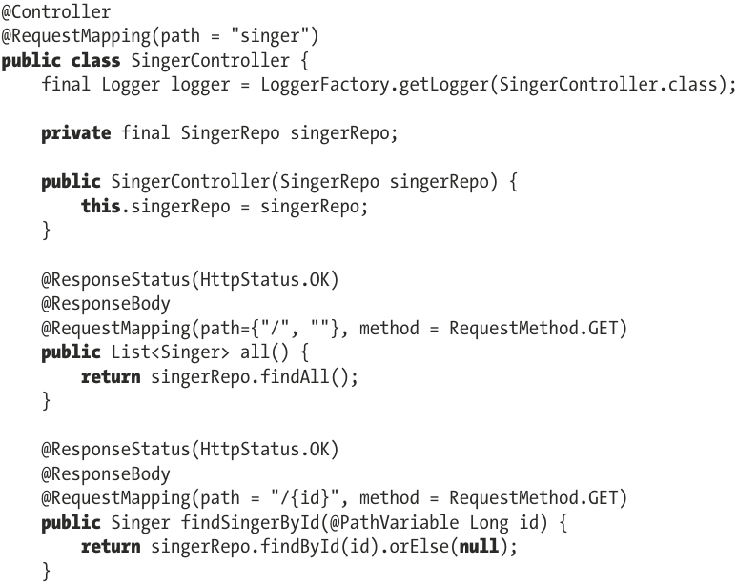

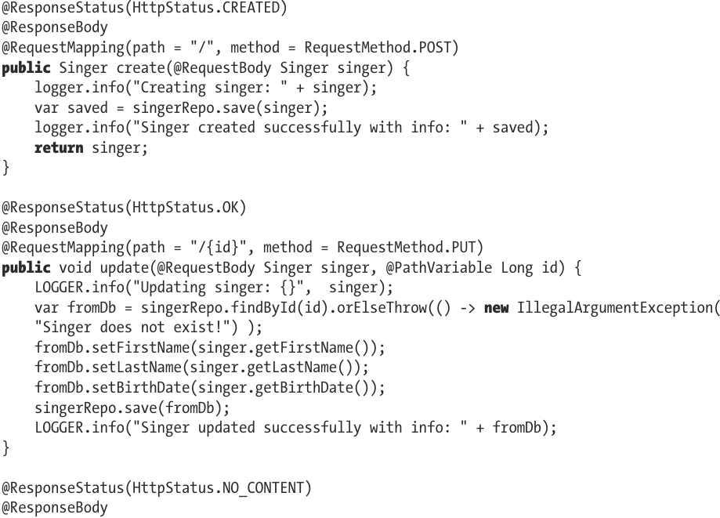

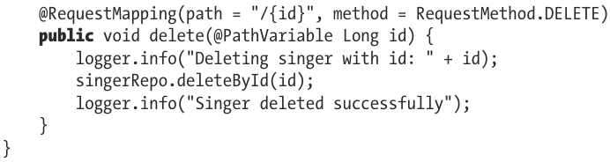

-Main points:

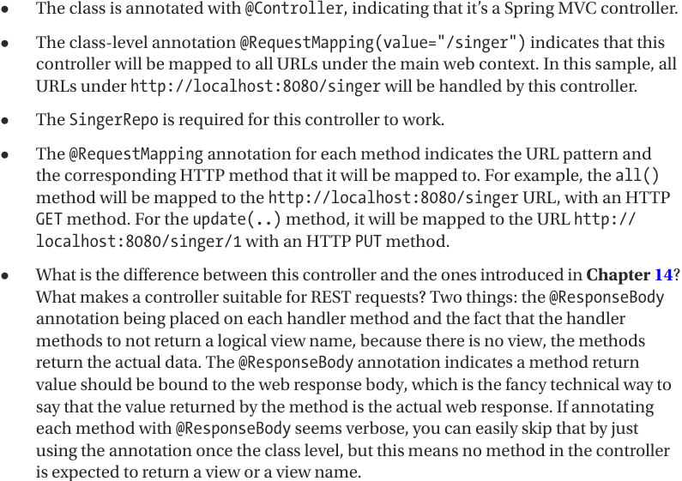

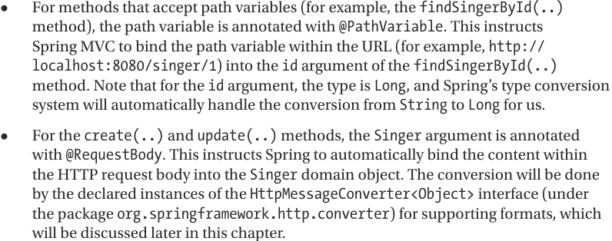

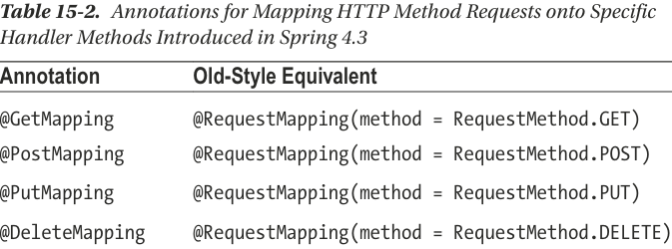

-**@RestController**=@Controller+@ResponseBody

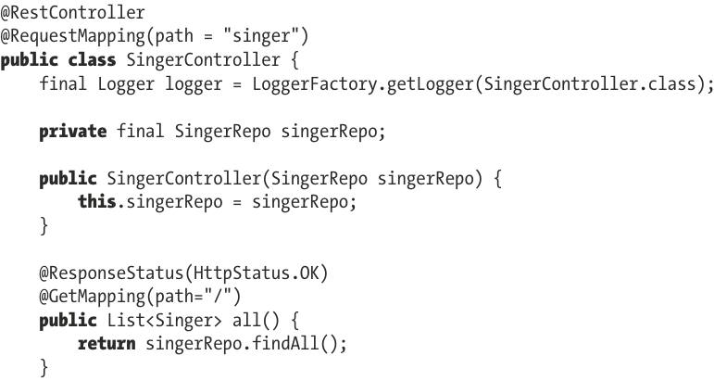

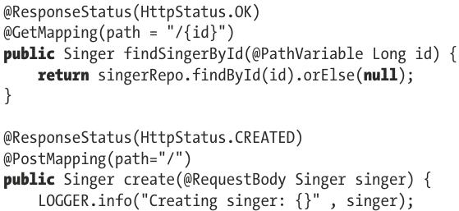

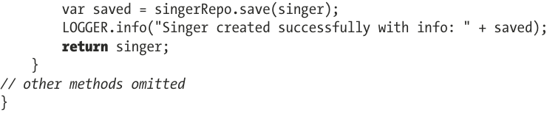

-**WebInitializer**: For Spring Web REST, no need for resolver beans, HiddenHttpMethodFilter:

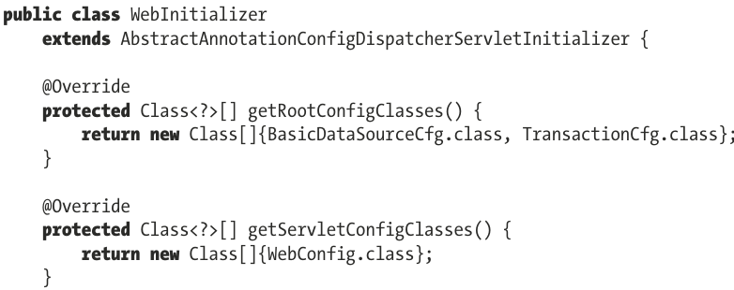

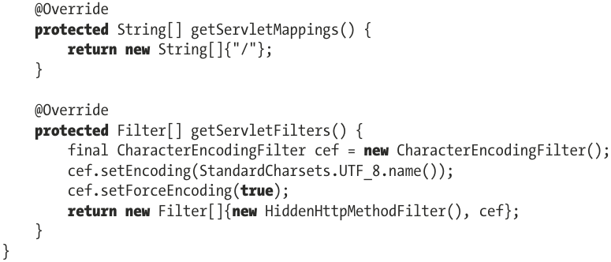

-**WebConfig**: no need for theming or i18n

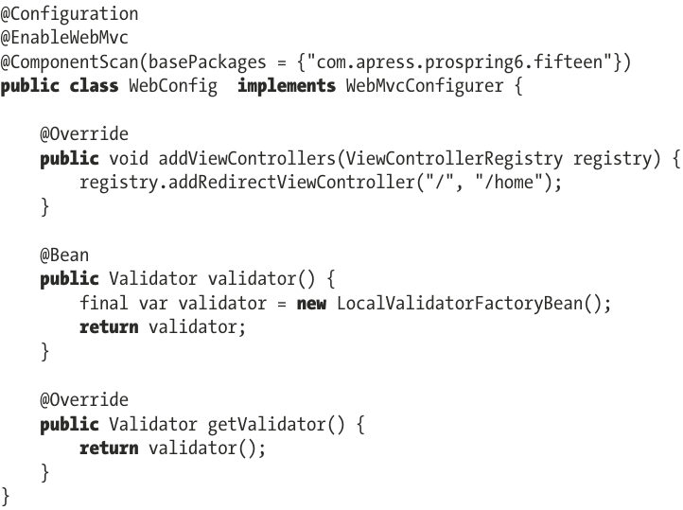

-Spring MVC determines the **requested media types** from request based on Accept header. You can configure requested media type by **configureContentNegotiation()** in WebConfig. The other way is **configureMessageConverters()** for default message converters or adding custom message converter with **extendMessageConverters()**

-Dependencies for Jackson library:

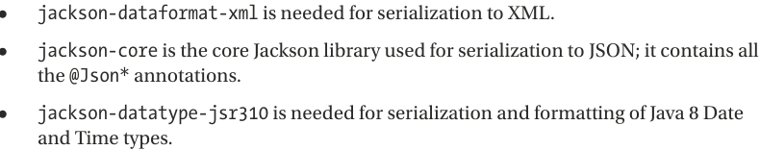

### 15.1.3 Test the RESTful-WS Application

-**RestTemplate**:

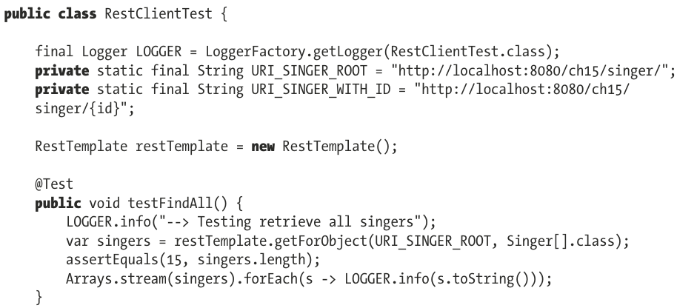

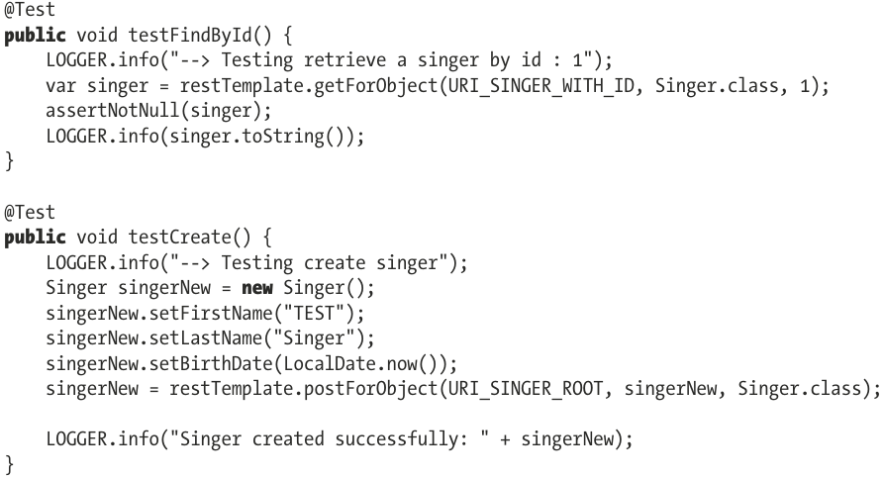

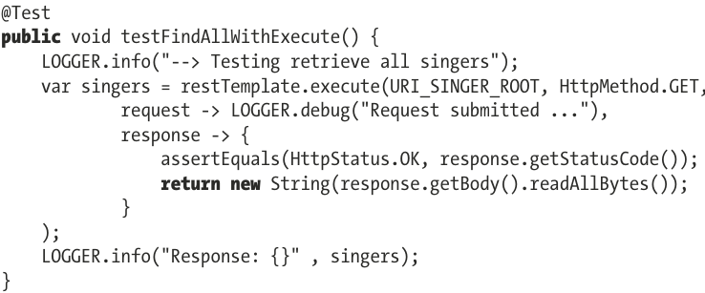

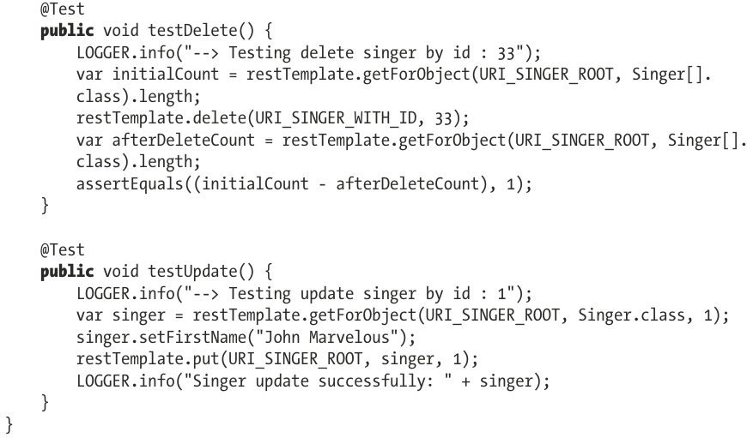

### 15.1.4 REST Exception Handling Using ResponeEntity<t>

-Return HttpStatus value via **ResponeEntity**<T>. This type is extension of HttpEntity<T> that includes HttpStatusCode. It can be used to wrap result of RestTemplate and **return type** in REST handler method.

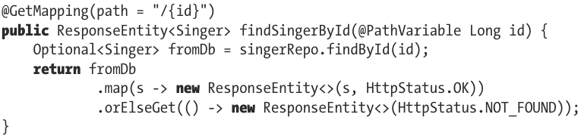

-For most common HTTP status codes, ResponseEntity<T> provides builder for constructing request:

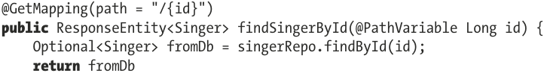

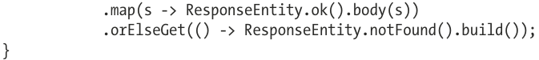

-Test:

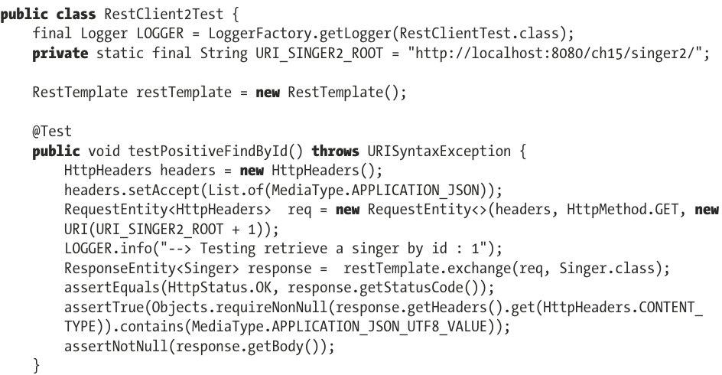

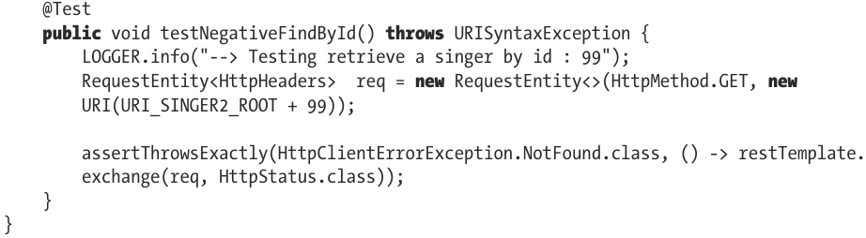

### 15.1.5 REST Exception Handling use @RestControllerAdvice

-To reduce code, write SingerService that wraps around SingerRepo and throws exception NotFoundException that **extends** **RuntimeException** (not checked exceptions). We inject bean of this type in controller and annotate **@ResponseStatus**(value=HttpStatus.NOT_FOUND) ->automatic mapping of this exception to response status that is returned to client.

-**NotFoundException** REST-Specific Exception:

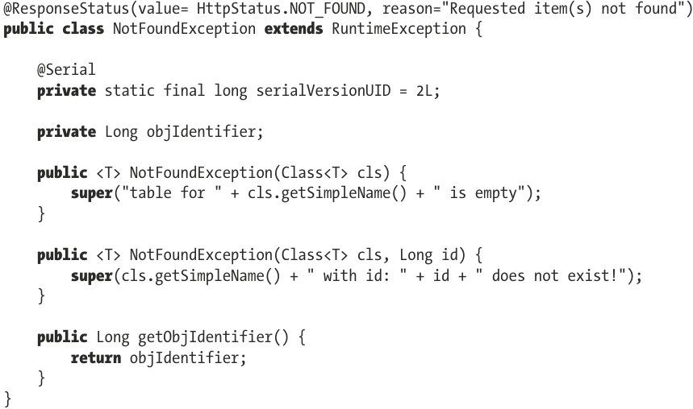

+reason attribute: error message

-**SingerService**:

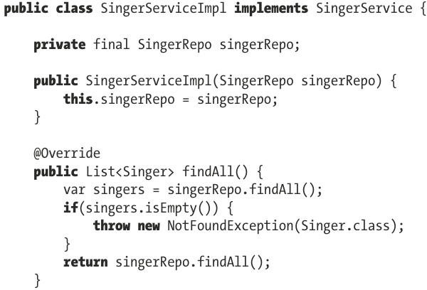

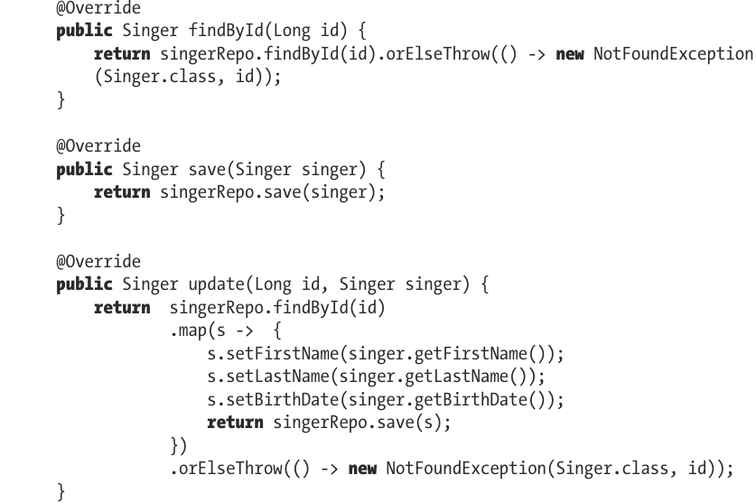

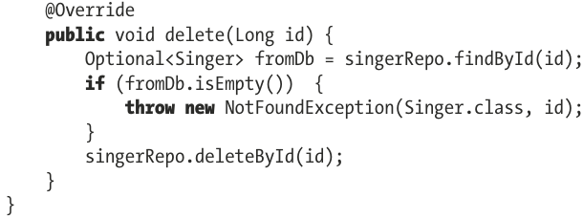

-**Singer3Controller**:

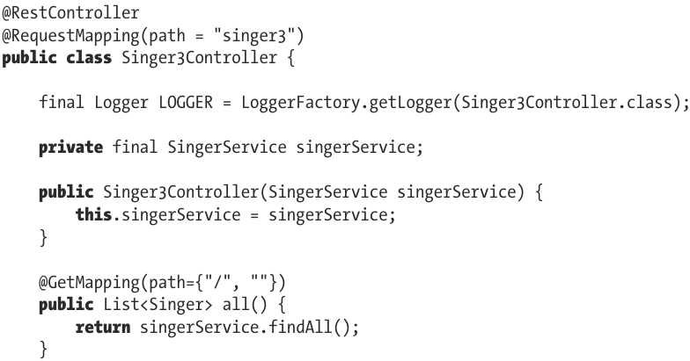

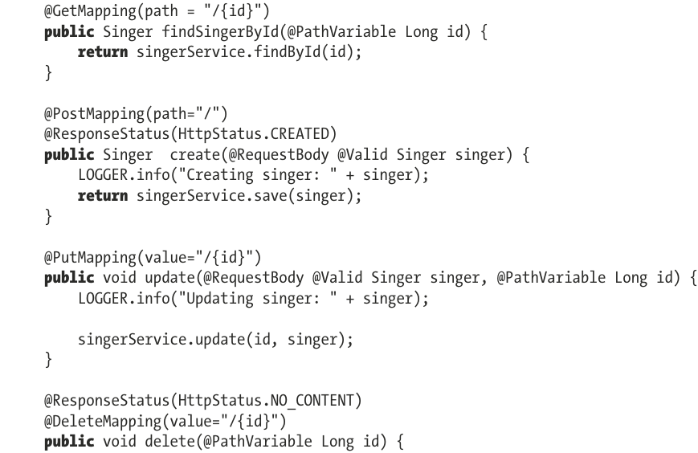

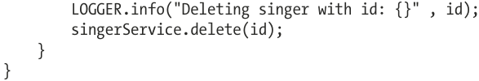

-For exceptions that is not part of our application: write exception handler class **@RestControllerAdvice** and declare method handler for exception:

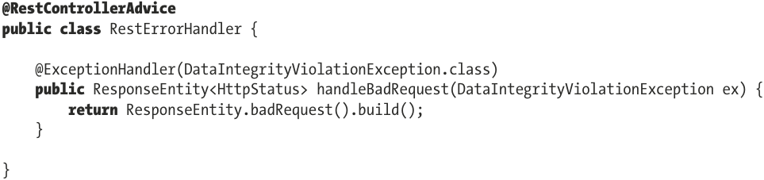

## 15.2 RESTful-WS with Spring Boot

-Dependencies: spring-boot-starter-web, spring-boot-starter-validation, spring-boot-starter-data-jpa, jackson-dataformat-xml

-Spring Boot configuration:

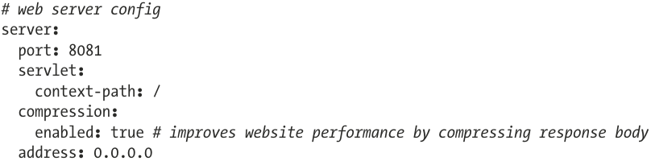

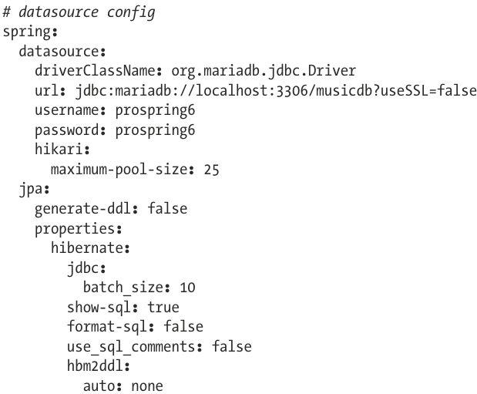

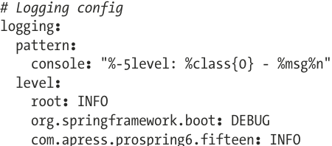

-Spring Boot Test Configuration:

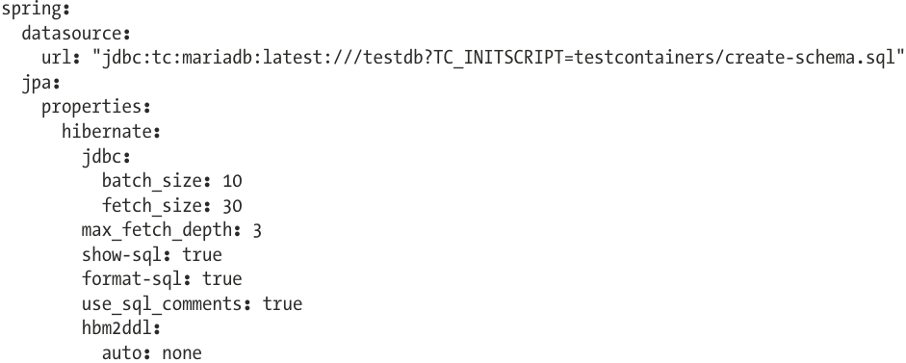

# 16 Spring Native and Other Goodies

## 16.1 Spring Native Images

-Spring Native image: a stand-alone executable created by processing a compiled Spring application ahead of time using GraalVM native-image compiler

-Spring Boot ability to create Docker images that contains Spring native executable and run application by starting up a container.

-A **native executable** is made of:

+Substrate VM: a VM compiled and configured for code that needs to be run on it

+DWARF info: information useful during debugging processes. DWARF is a debugging information file format used by many compilers

+Initial heap: Memory for application to run

+Native machine code: Low level code to run on a particular OS

+Application compiled to native code: Spring Boot application and dependencies

-**ahead-of-time (AOT) compilation**: Spring application transformed into a native executable

+Java code is generated

+Bytecode is generated for dynamic proxies

+The following GraalVM JSON hint are generated that describe how GraalVM should deal with things it can’t understand by inspecting the code

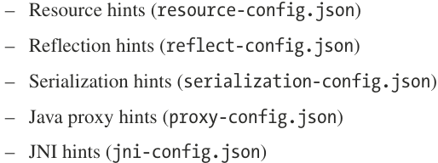

-2 ways to build Spring Boot native image app:

+Use SB support for Cloud Native Buildpacks to generate a container containing a native executable

+Use GraalVM Native Build Tools to generate a native executable

### 16.1.1 The Application

-(See in book)

### 16.1.2 The Configuration

-Gradle Configuration;

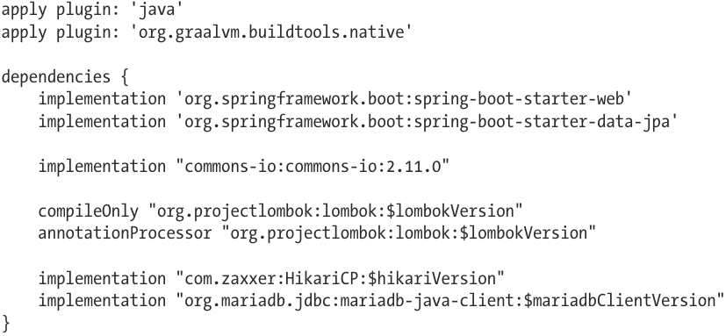

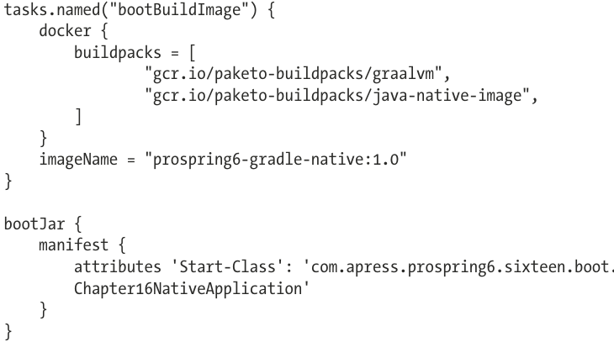

+GraalVM Native Image plug-in: org.graalvm.buildtools.native

## 16.2 Spring for GraphQL

## 16.3 Spring Kotlin Applications

### 16.3.1 The Configuration

### 16.3.2 The Code

# 17. Securing Spring Web Applications

## 17.1 Configure Spring Security: The Classic Way

-Dependencies:

+spring-security-config: contains Java configuration support

+spring-security-web: web security infrastructure code (filters, Servlet API dependencies)

-Spring Security is complex, the official documentation explains very well.

-Once Spring Security is configured, HTTP requests are intercepted by Security Interceptor and access to resources is decided based on user. Security Interceptor works with a preprocessing step and a postprocessing step.

+**Preprocessing step**: look to see whether requested resource is secured with some metadata information represented by **ConfigAttribute**. If not, request is allowed to continue its way either to requested URL or method. If requested resource is secured, Security Interceptor retrieves **Authentication** object from current **SecurityContext**. If necessary, Authentication object will be authenticated against the configured **AuthenticationManager**.

-**Intercepting** all requests requires a special **servlet filter**. Spring Security filter name **springSecurityFilterChain**: a collection of filters that are chained together to protect URLs, validate usernames and passwords, redirect to login form…

-Make **springSecurityFilterChain** is the **entry point** to application, registered with **highest precedence**, to be the 1st filter in the chain, before any other registered Filter: implement **WebApplicationInitializer**

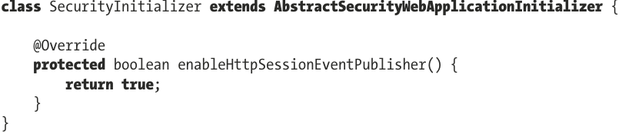

+**AbstractSecurityWebApplicationInitializer**: benefit from the default Spring implementation

+**enableHttpSessionEventPublisher()**: return **true** if session management has specified a maximum number of sessions, **HttpSessionEventPublisher** is added to notify session registry when users log out.

-With a **default configuration**, a **default simple login page** is included, any request requiring authentication is redirect to it.

-**SecurityCfg**

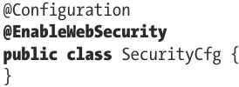

+It sets up securityFilterChain with a default configuration, all requests are blocked, you are directed to login screen.

-**AuthenticationProdiver**: look for username and password to match.

-**UserDetailService**: load user information from source (database, memory…)

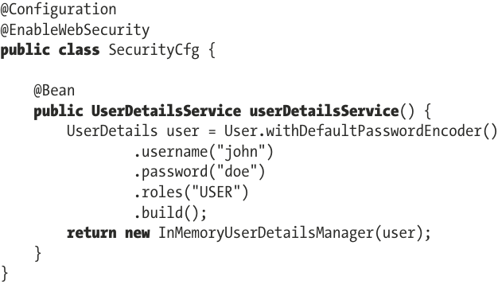

+This configuration works:

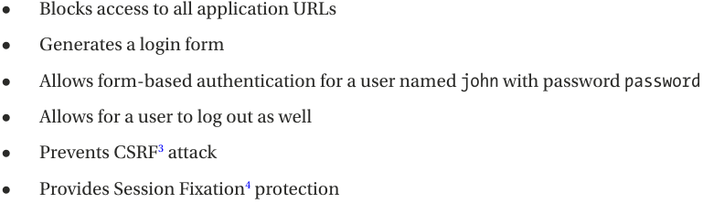

+**User.withDefaultPasswordEncoder():** delegates to BCryptPasswordEncoder.

-You can explicitly declare password encoder:

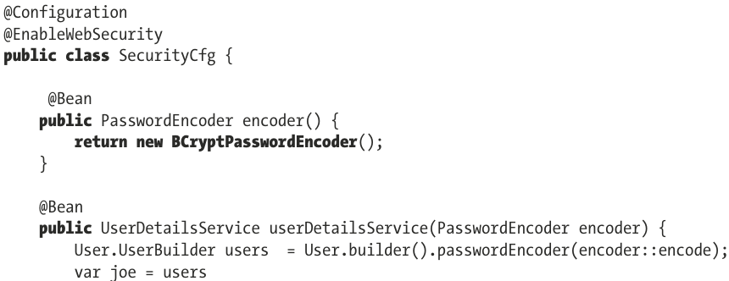

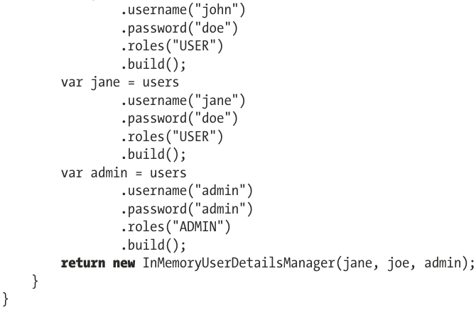

-**@EnableWebSecurity**: enable secured behavior, expose **SecurityFilterChain** bean and customize it:

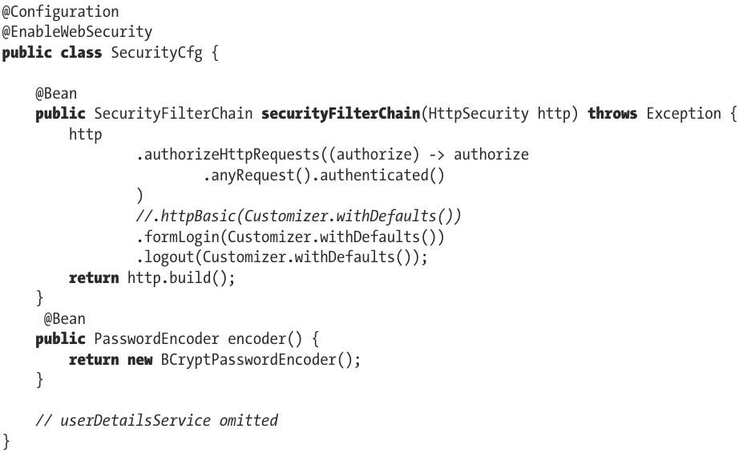

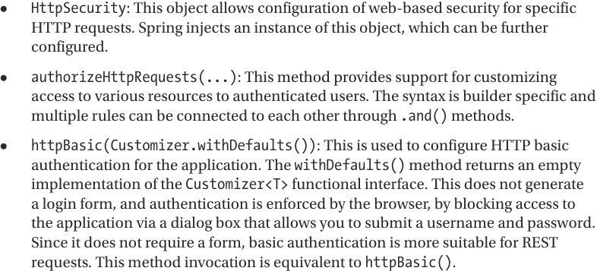

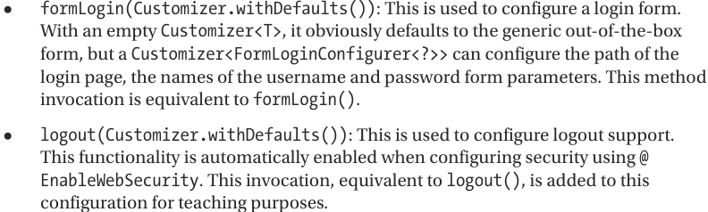

-Custom form login:

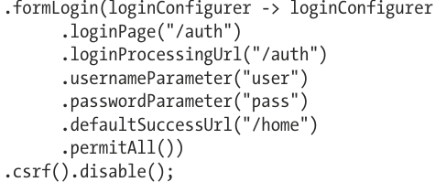

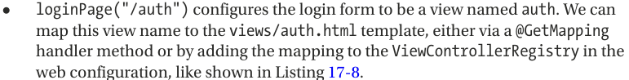

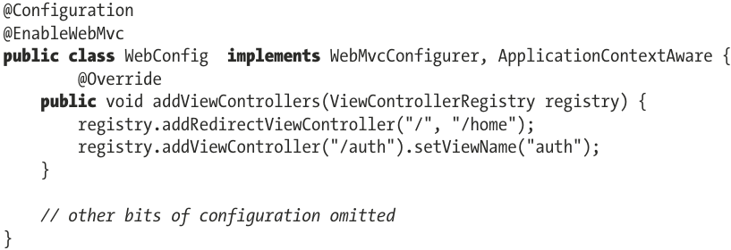

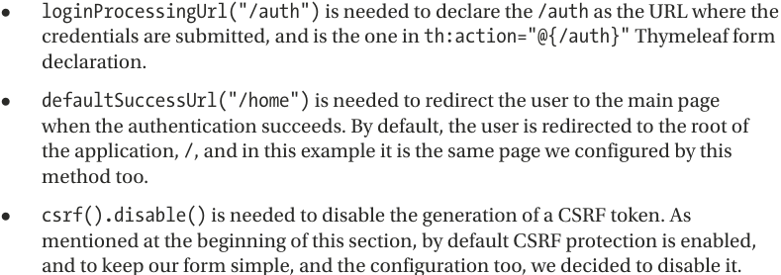

-Default configuration will require changes and adjustment in real application:

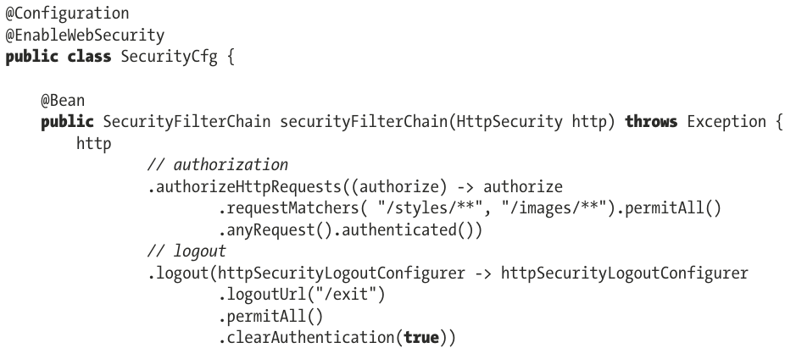

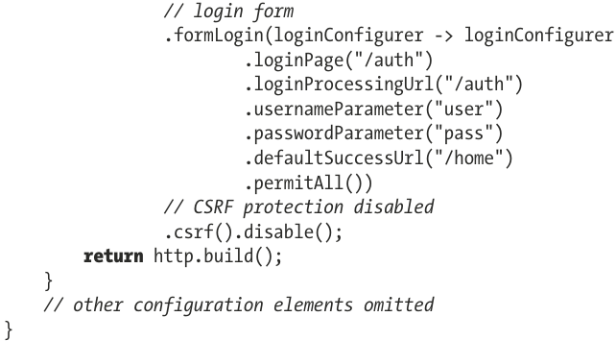

-Add SecurityCfg to collection of configuration classes that define our application context.

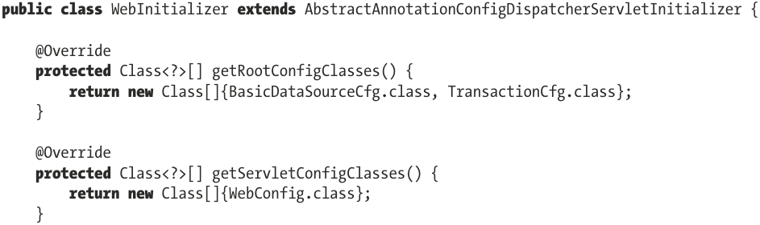

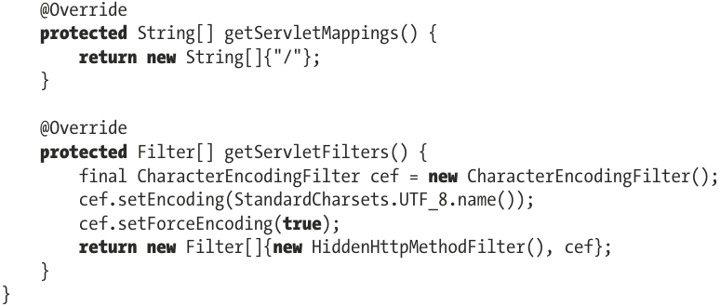

-ApplicationConfiguration Class: pick up all configuration. So security context spans through multiple layers.

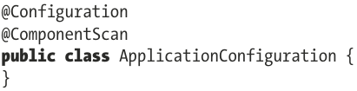

+This class is used as a single configuration entry point in WebInitializer:

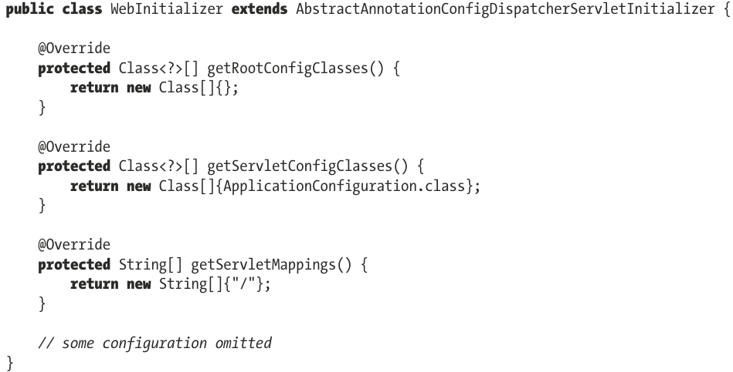

-WebConfig:

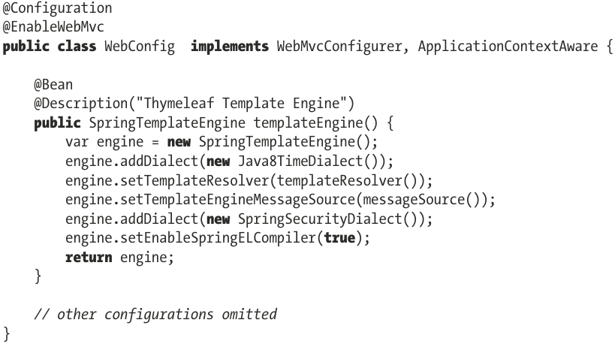

-Role name isn’t case sensitive: hasRole(‘admin’)=hasRole(‘ADMIN). By default it add ROLE_ prefix.

-For each application user, authorities and roles are configured. Both are represented by **List<GrantedAuthority>**

+GrantedAuthority interface represents authority granted to an Authentication object, thus a permission.

+role is a GrantedAuthority with name prefixed ROLE_

+Spring security might be configured to treat roles differently than authorities.

-Spring Security SpEL expressions for configuring authorization:

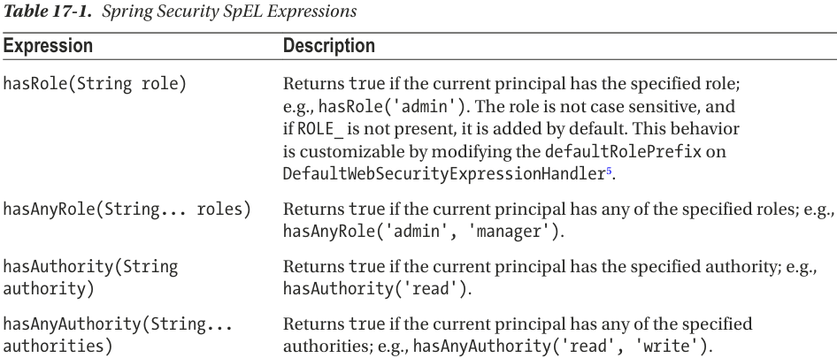

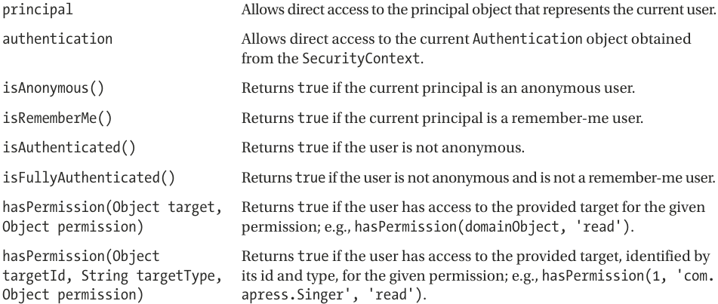

-**org.springframework.security.access.prepost**: define security-specific actions before and after execution of method.

+**@PreAuthorize**: evaluate to decide whether a method invocation is allowed or not

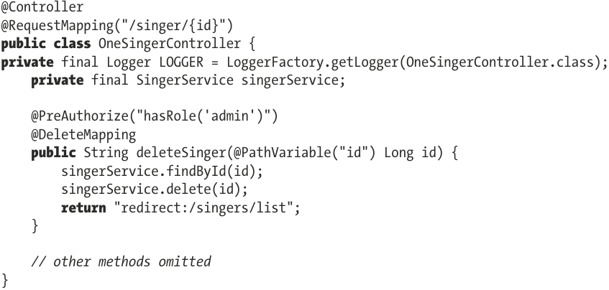

**-@ControllerAdvice**: redirect user to views/error.html

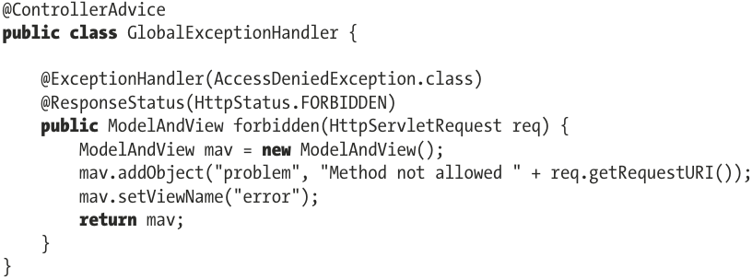

-**SecurityCfg**:

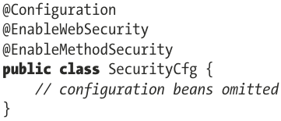

-**prepost package** contains 4 annotations allow pre- and post-invocation authorization checks and support filtering of submitted collection arguments or return values: @PreAuthorize, @PreFilter, @PostAuthorize, @PostFilter.

+By default, the support for these methods is enabled by **@EnableMethodSecurity**. They can **disabled** by: @EnableSecurity(prePostEnabled=false)

-Enable **@Security**: @EnableMethodSecurity(secured=true). By default, secured=false

-**Jakarta Security annotations**: @RolesAllowed, @DenyAll, @PermitAll, @RunAs, @DeclareRoles

+Enable: @EnabledMethodSecurity(jsr250Enabled=true). By default, it’s false

-Abstract schema of a secured method execution

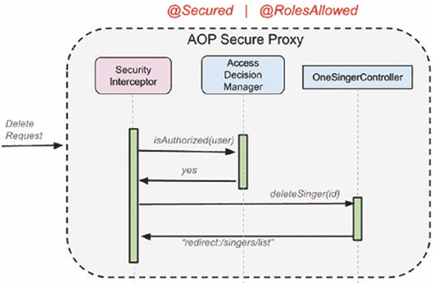

### 17.1.1 JDBC Authentication

-For production application, credentials are stored in relational databases. It’s practical to add tables for storing credentials and groups.

-Schema packed in spring-security-core:

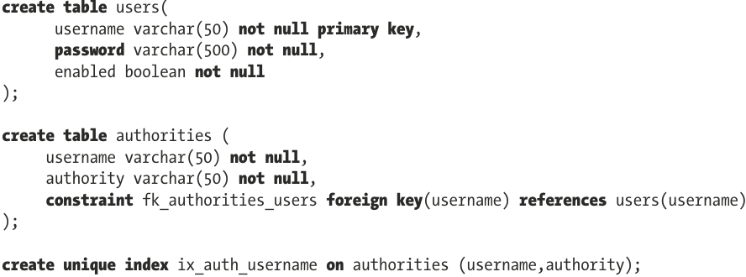

-**UserDetailsManager**: extend UserDetailService to populate these tables.

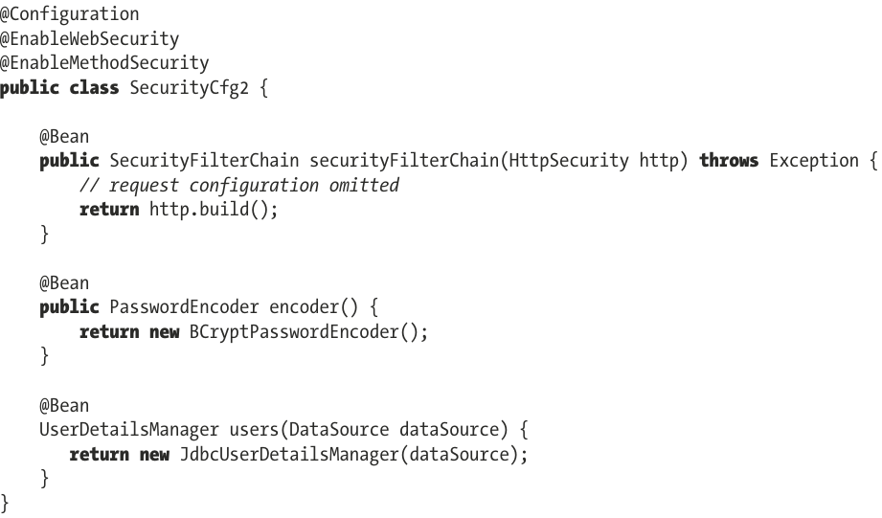

-You an provide a **Custom implementation** of **UserDetailsService** for retrieving users and authorities based on user-provided data.

-Or You can use **AuthenticationManagerBuilder** bean:

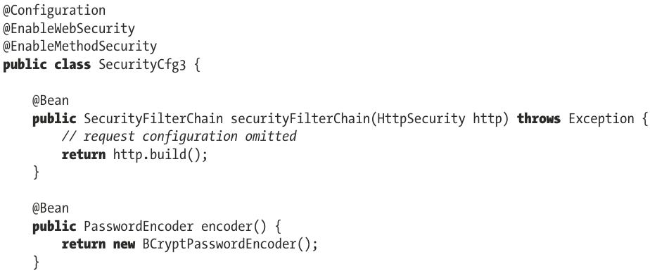

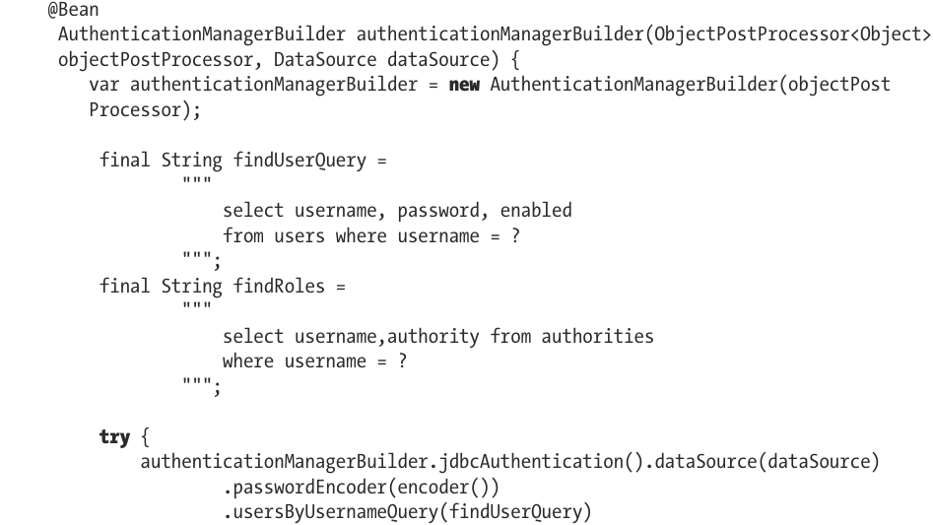

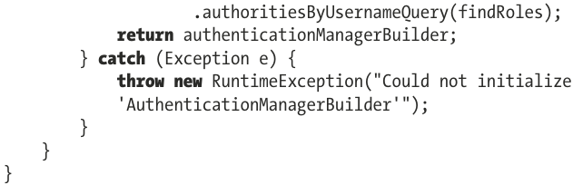

### 17.1.2 Testing Secured Web Applications

## 17.2 Configure Spring Security: The Spring Boot way

-Dependencies: spring-boot-starter-security

-Without any specific security configuration, Spring Boot sets up in-memory authentication and generates password used with user named user

+Customize default user and password:

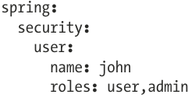

-The easiest way to customize security configuration in Spring Boot is to **disable** Spring Boot **security** **autoconfiguration** and build our classes from scratch: **exclude** **SecurityAutoConfiguration** class

+In @SpringBootApplication



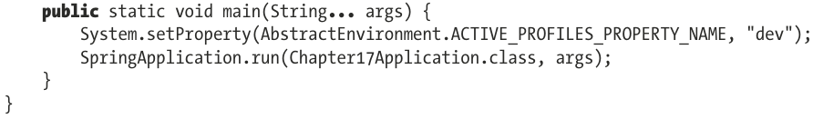

+In properties file:

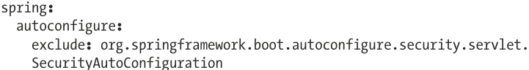

-**Read about Spring Security in depth**: Pro Spring Security for Spring 6 and Spring Boot 3

# 18. Monitoring Spring Applications

## 18.1 JMX Support in Spring

### 18.1.1 Exporting a Spring Bean to JMX

### 18.1.2 Using VisualVM for JMX Monitoring

### 18.1.3 Monitoring Hibernate Statistics

## 18.2 JMX with Spring Boot

## 18.3 Monitoring Applications with Spring Boot Actuator

### 18.3.1 Spring Boot Actuator Endpoints

### 18.3.2 Use Spring Boot Actuator with Micrometer

# 19. Spring WebSocket Support

## 19.1 Introduce WebSocket

## 19.2 Use WebSocket with Spring

## 19.3 Use WebSocket API

## 19.4 Use SockJS

## 19.5 Send Messages with STOMP

### 19.5.1 Spring Boot Equivalent Application